Activity Solutions

# CHAPTER 1: UNDERSTANDING KUBERNETES AND CONTAINERS

## ACTIVITY 1.01: CREATING A SIMPLE PAGE COUNT APPLICATION

### Solution:

While you can use any programming language and datastore of your choice, we will go with Golang and Redis for this solution.

### A PageView Web App

1. Create a **main.go** file using the following source code:

package main

import (

"fmt"

"log" "net/http"

)

var pageView int64 func main() {

http.HandleFunc("/", handler) log.Fatal(http.ListenAndServe("0.0.0.0:8080", nil))

}

func handler(w http.ResponseWriter, r *http.Request) { log.Printf("Ping from %s", r.RemoteAddr) pageView++

fmt.Fprintf(w, "Hello, you're visitor #%d !", pageView)

}

1. Create a file named **Dockerfile** with the following content:

FROM alpine:3.10 COPY main /

CMD ["/main"]

1. Now, build the executable **pageview-v1** binary using the following command:

CGO_ENABLED=0 GOOS=linux GOARCH=amd64 go build -o main

1. Use the following command to build the Docker image:

docker build -t <username>/pageview:v0.0.1 .

1. Now, push it to Docker Hub using this command. Please use your Docker Hub username here:

docker push <username>/pageview:v0.0.1

Create the **pageview-v1** container and map port 8080 of the host to the same port on the container, as shown here:

docker run --name pageview -p 8080:8080 -d <username>/pageview:v0.0.1

Use the appropriate **username** and tag.

**NOTE**

If you are having problems with building your own image, you can use the one that we have provided by using this repository path in the preceding command: **fenago/the-kubernetes- workshop:pageview**.

You should see the following response:

6cdcf461356e147cdfc2ef61104600588daddb387dff5f974954e46d35940827

1. Access the application multiple times to ensure that the pageview number increases every time. Run the following command repeatedly:

curl localhost:8080

You should see a response similar to the following:

root@ubuntu:~# curl localhost: 8080 Hello, you're visitor #1. root@ubuntu:~# curl localhost: 8080 Hello, you're visitor #2. root@ubuntu:~# curl localhost: 8080 Hello, you're visitor #3.

### Bonus Objective: A Backend Datastore

1. We will use Redis for this solution. Use the following command to fetch and run the Redis container:

docker run --name db -d redis

The following response indicates that Redis has been downloaded and started successfully:

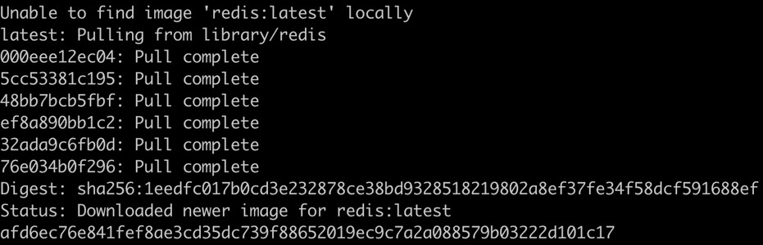

**Figure 1.32: Starting up Redis**

The preceding command creates a container named **db**, using the latest

**redis** image.

1. Now check the status of the container as well as the exposed port:

docker ps

You should see a response similar to this:

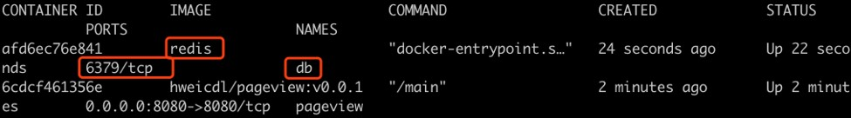

**Figure 1.33: Checking our containers**

In this case, port **6379** is exposed, which we will use for the next part of the solution.

### Bonus Objective: Modifying the Web App to Connect to a Backend Datastore

* 1. To persist the pageview number, we're going to connect to the backend **db** (Redis), and then increase the number by 1 each time. The modified version of **main.go** should look like this:

package main

import (

"fmt"

"log" "net/http"

"github.com/go-redis/redis/v7"

)

var dbClient *redis.Client var key = "pv"

func init() {

dbClient = redis.NewClient(&redis.Options{

Addr: "db:6379",

})

}

func main() {

http.HandleFunc("/", handler) log.Fatal(http.ListenAndServe("0.0.0.0:8080", nil))

}

func handler(w http.ResponseWriter, r *http.Request) { log.Printf("Ping from %s", r.RemoteAddr) pageView, err := dbClient.Incr(key).Result() if err != nil {

panic(err)

}

fmt.Fprintf(w, "Hello, you're visitor #%v.\n", pageView)

}

Here are a few things worth noting:

The database connection address is specified as **db:6379**. The **db** alias will be dynamically interpreted to its IP when the Redis container is linked to the **pageview-v2** container during runtime.

We are using **dbClient.Incr(key)** so that the pageview number increases by 1 on the **db** server-side, and the **db** server can deal with racing conditions when several clients try to write at the same moment.

* 1. Proceed with compiling the binary and building a container out of it, just like we did with **pageview-v1**. Use the following commands:

CGO_ENABLED=0 GOOS=linux GOARCH=amd64 go build -o main docker build -t <username>/pageview:v0.0.2 .

docker push <username>/pageview:v0.0.2

* 1. Remove the **pageview-v1** container first, and then launch the **pageview-v2**

container using these commands one after the other:

docker rm -f pageview

docker run --name pageview --link db:db -p 8080:8080 -d <username>/ pageview:v0.0.2

**NOTE**

If you are having problems with building your own image, you can use the one that we have provided by using this repository path in the preceding command: **fenago/the-kubernetes- workshop:pageview-v2**.

You should see the following response:

acdb5f271d08a294215147371c9b113d417d93727e338059d1a66e1b4e53fc55

* 1. Let's check whether the correct containers are running by listing the containers:

docker ps

You should see a response similar to the following:

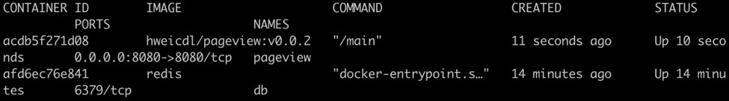

**Figure 1.34: Getting a list of all of the containers**

* 1. Access the **pageview-v2** multiple times, and check whether the number increases by 1 each time. Use this command repeatedly:

curl localhost:8080

You should see the following response:

root@ubuntu:~# curl localhost: 8080 Hello, you're visitor #1. root@ubuntu:~# curl localhost: 8080 Hello, you're visitor #2. root@ubuntu:~# curl localhost: 8080 Hello, you're visitor #3.

* 1. Now, let's kill and restart the **pageview-v2** container, and see whether the pageview number can still be calculated properly. First, let's restart the container by using the following commands one after the other:

docker rm -f pageview

docker run --name pageview --link db:db -p 8080:8080 -d <username>/ pageview:v0.0.2

You should see a response similar to the following:

1e04fed99b7faaf37d30245975b3b15baf4a1bf711ddc9dfb7eb29095f4b8582

* 1. Now, try accessing our application:

curl localhost:8080

You should see the following response:

Hello, you're visitor #4.

The result shows that it's the fourth visit instead of the first. In this case, we accessed our application three times before terminating it. The count then started at 4 when we restarted it. Therefore, we can conclude that the state of the application was persisted.

# CHAPTER 2: AN OVERVIEW OF KUBERNETES

## ACTIVITY 2.01: RUNNING THE PAGEVIEW APP IN KUBERNETES

### Solution:

In this activity, we are going to migrate the Pageview app created in the previous chapter to Kubernetes.

### Connecting the Pageview App to the Redis Datastore Using a Service

1. For the frontend, create a file named **k8s-pageview-deploy.yaml** with the following content:

apiVersion: apps/v1 kind: Deployment metadata:

name: k8s-pageview spec:

replicas: 1 selector:

matchLabels: tier: frontend

template: metadata:

labels:

tier: frontend spec:

containers:

- name: k8s-pageview

image: **fenago/the-kubernetes**-workshop:pageview

**NOTE**

In the **image** field, use the same location that you used in the previous chapter. If for some reason, you don't have the image and the repository path from the previous chapter, you can use this YAML config as-is in order to use the pre-made images that are provided as part of the solution.

1. For the Redis datastore backend, create a file named **k8s-redis-deploy. yaml** with the following content:

apiVersion: apps/v1 kind: Deployment metadata:

name: k8s-redis spec:

replicas: 1 selector:

matchLabels: tier: backend

template: metadata:

labels:

tier: backend spec:

containers:

- name: k8s-redis image: redis

1. To define a Service for internal traffic routing, create a file named

**k8s-redis-internal-service.yaml** with the following content:

kind: Service apiVersion: v1 metadata:

name: db spec:

selector:

tier: backend ports:

- port: 6379

targetPort: 6379

1. Use the following commands one after the other to apply the three YAML manifests we've created so far:

kubectl apply -f k8s-redis-deploy.yaml

kubectl apply -f k8s-redis-internal-service.yaml kubectl apply -f k8s-pageview-deploy.yaml

You should see the following response:

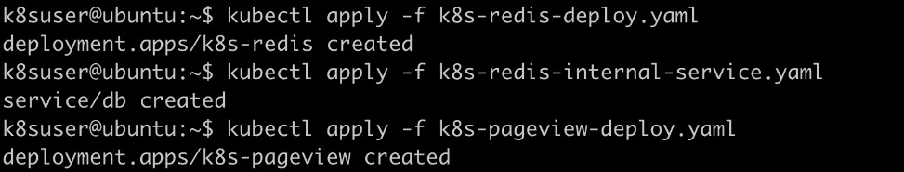

**Figure 2.31: Creating the required Deployments and Service**

1. Now, let's check whether the Deployments and the Service have been

created successfully:

kubectl get deploy,service

You should see the following output:

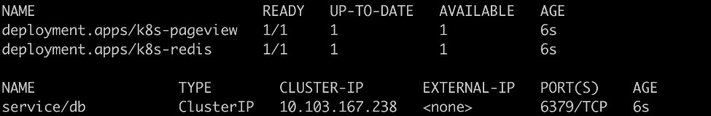

**Figure 2.32: Getting the list of Deployments and Services**

1. For the NodePort Service, create a file named **k8s-pageview-external- service.yaml** with the following content:

kind: Service apiVersion: v1 metadata:

name: k8s-pageview spec:

selector:

tier: frontend type: NodePort ports:

- port: 80

targetPort: 8080

1. Let's apply the spec we created in the previous step:

kubectl apply -f k8s-pageview-external-service.yaml

You should see the following output:

service/k8s-pageview created

1. Let's check the URL that we will use to access our Service:

minikube service k8s-pageview

You should see a response similar to the following:

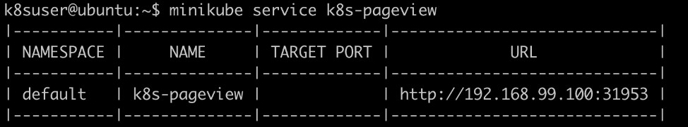

**Figure 2.33: Getting the URL and port to access the NodePort Service**

1. Try accessing the external access endpoint of the Pageview app:

curl <service endpoint>:<node port>

Please use the URL from the previous step that you get in your case. You should see a response similar to the following:

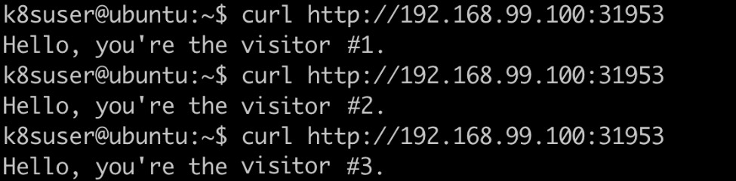

**Figure 2.34: Accessing the application and confirming that the visitor count increases**

### Running the Pageview App in Multiple Replicas

Now that we have our Pageview app connected to a backend datastore, let's scale up the number of replicas of the frontend:

1. Now, make the following edits to **k8s-pageview-deploy.yaml** to increase the replicas to three:

apiVersion: apps/v1 kind: Deployment metadata:

name: k8s-pageview spec:

# replicas: 1

**replicas: 3**

selector: matchLabels:

tier: frontend template:

metadata: labels:

tier: frontend spec:

containers:

- name: k8s-pageview

image: **fenago/the-kubernetes**-workshop:pageview

As you can see, we have increased the number of **replicas** to **3**.

1. Apply the changes and bring the edited spec into effect:

kubectl apply -f k8s-pageview-deploy.yaml

You should see the following response:

deployment.apps/k8s-pageview configured

1. Check the number of pods that we have now:

kubectl get pod

You should see an output similar to the following:

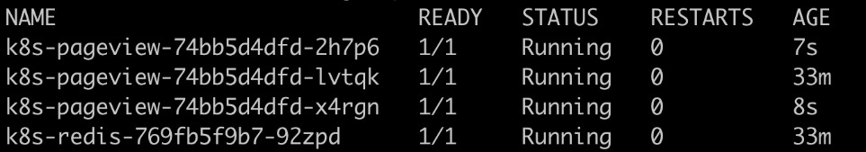

**Figure 2.35: Getting the list of pods**

We can see that we have three pageview pods running.

1. Let's confirm once again that our application is running:

curl <service endpoint>:<node port>

You should see a response similar to the following:

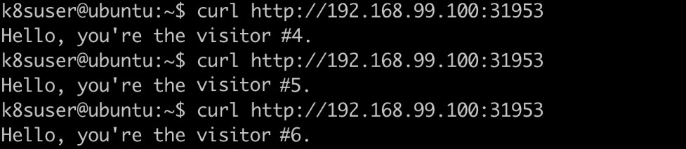

**Figure 2.36: Repeatedly accessing the application**

1. Let's check the logs of each pod:

kubectl logs <pod name>

Run this command for each of the three pods running the frontend of our application. You should see a response similar to the following:

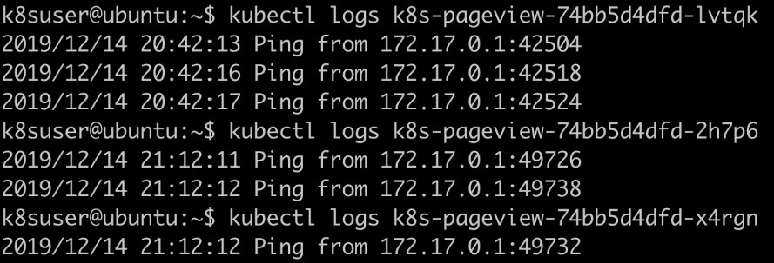

**Figure 2.37: Getting the logs of the pod replicas running the application**

The result may vary, but it will be somewhat similar to what you can see in the previous screenshot – some pods get more requests than others as the distribution is not perfectly even for a small sample size.

1. We will create a Bash script to simulate killing pods continuously. For this script,

create a file named **kill-pods.sh** with the following content:

#!/usr/bin/env bash

# Sleep 1 second in each cycle.

SLEEP_INTERVAL=1

while true; do

# Always keep one Pod running.

running_pod_kept=

# In each cycle, get the running Pods, and fetch their names. kubectl get pod -l tier=frontend --no-headers | grep Running

| awk '{print $1}' | while read pod_name; do # Keep the 1st Pod running.

if [[ -z $running_pod_kept ]]; then running_pod_kept=yes

echo "Keeping Pod $pod_name running" # Delete all other running Pods.

else

echo "Killing Pod $pod_name" kubectl delete pod $pod_name

fi

done

sleep $SLEEP_INTERVAL

done

1. Similarly, we can also create a Bash script to simulate repeatedly accessing our application. For this, create a file named **access-pageview.sh** with the following content:

#!/usr/bin/env bash

# Sleep 1 second in each cycle.

SLEEP_INTERVAL=1

while true; do

**curl http://192.168.99.100:31953**

sleep $SLEEP_INTERVAL

done

**NOTE**

The highlighted URL (in this example, we have **http://192.168.99.100:31953**) needs to be replaced with the **<service endpoint>:<node port>** that you get for your environment.

1. Now, open two terminal windows. In the first one, let's call the script to kill

the pods:

./kill-pods.sh

You should see an output similar to the following:

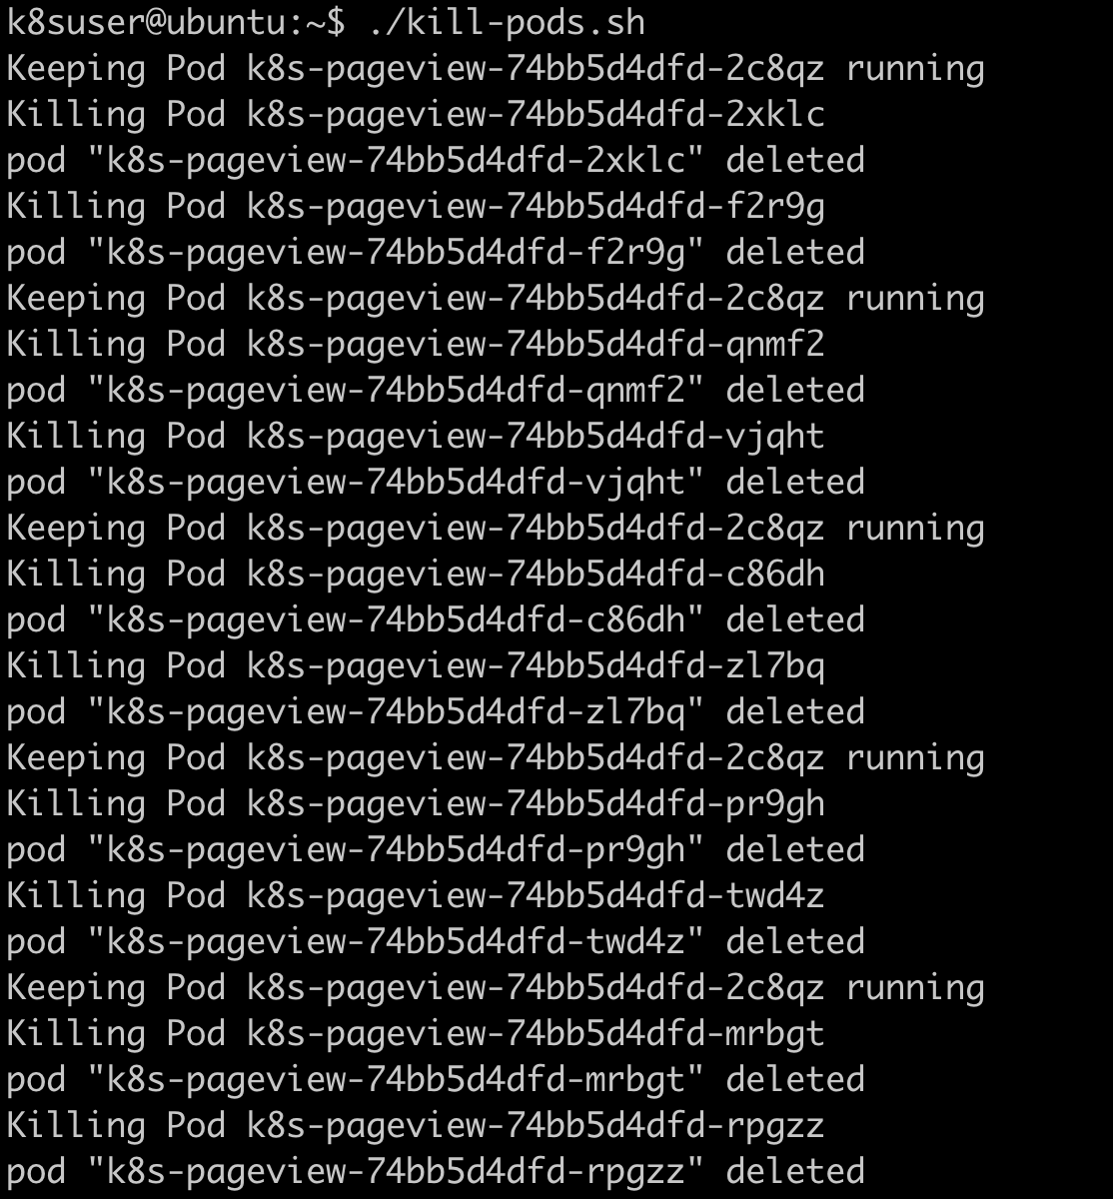

**Figure 2.38: Killing pods via a script**

In this output, we can see that the script kills a pod every 1 second.

1. In the other terminal window, call the script to repeatedly access our application:

./access-pageview.sh

You should see an output similar to the following:

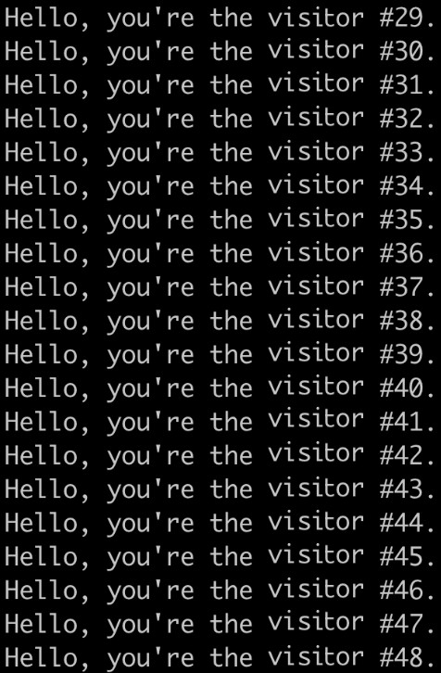

**Figure 2.39: Repeatedly accessing the application via the script**

From the preceding output, we can tell that the availability of the Pageview app isn't impacted – we can still visit it without running into any errors, even though we have a script that's constantly killing pods.

Press *Ctrl* + *C* in both terminal windows to terminate the respective scripts.

# CHAPTER 3: KUBECTL – THE KUBERNETES COMMAND CENTER

## ACTIVITY 3.01: EDITING A LIVE DEPLOYMENT FOR A REAL-LIFE APPLICATION

### Solution:

This section shows a sample solution regarding how to deploy a sample real-life application and make it accessible to the public. While this solution can be adapted for any platform (cloud or local) and any application, for reference, we are using the application that we provided with Minikube. Perform the following steps to complete this activity:

1. Use the following command to get the definition of the application:

curl https://raw.githubusercontent.com/PacktWorkshops/Kubernetes- Workshop/master/Chapter03/Activity03.01/sample-application.yaml

--output sample-application.yaml

1. Use the following command to deploy this YAML manifest file to your

current cluster:

kubectl apply -f sample-application.yaml

You can expect an output similar to the following:

deployment.apps/redis-back created service/redis-back created deployment.apps/melonvote-front created service/melonvote-front created

This indicates that you have created the related Kubernetes objects successfully.

1. You can use the following command to get the statuses of the current pods and monitor their Deployment statuses:

kubectl get pod

You can expect an output similar to the following:

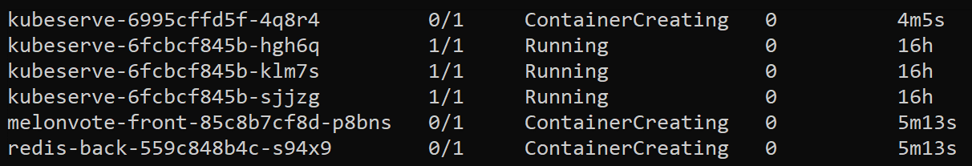

**Figure 3.17: Using the kubectl get command to check pods**

This indicates that the pods are running in the default namespace.

1. Use the following command to get all the services that have been created in the default namespace:

kubectl get svc

You can expect an output similar to the following:

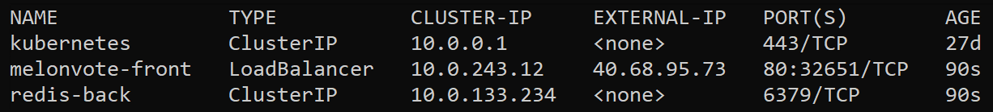

**Figure 3.18: Using the kubectl get command to check the services**

If this has been performed on any cloud providers that support load balancers, it would have provisioned an external IP address so that users could access the frontend application. However, when setting the **LoadBalancer** type on Minikube, it makes the service accessible through the **minikube service** command.

1. Use the following command to get the IP and port so that we can access our application:

minikube service melonvote-front

You should see the following output:

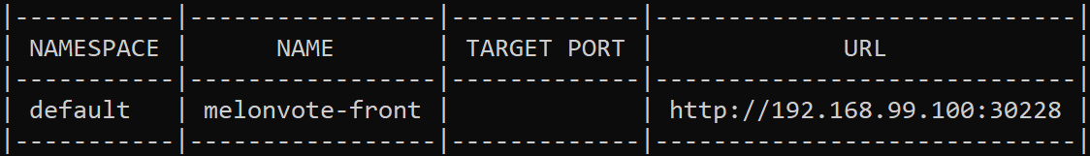

**Figure 3.19: Using the minikube service command to check the melonvote-front service**

Note the URL shown in the preceding image. If you're using a cloud provider instead of Minikube for this activity, you can also use the following command:

kubectl get svc melonvote-front

You can expect an output similar to the following:



**Figure 3.20: Using the kubectl get command to check the melonvote-front service**

1. Get the list of Deployments:

kubectl get deploy

You can expect an output similar to the following:

|  |  |  |  |  |
| --- | --- | --- | --- | --- |
| NAME | READY | UP-TO-DATE | AVAILABLE | AGE |
| aci-helloworld | 1/1 | 1 | 1 | 27d |
| kubeserve | 1/1 | 1 | 1 | 6h27m |
| redis-back | 1/1 | 1 | 1 | 6h27m |

1. Now, let's edit the **melonvote-front** Deployment:

kubectl edit deploy melonvote-front

You can expect an output similar to the following:

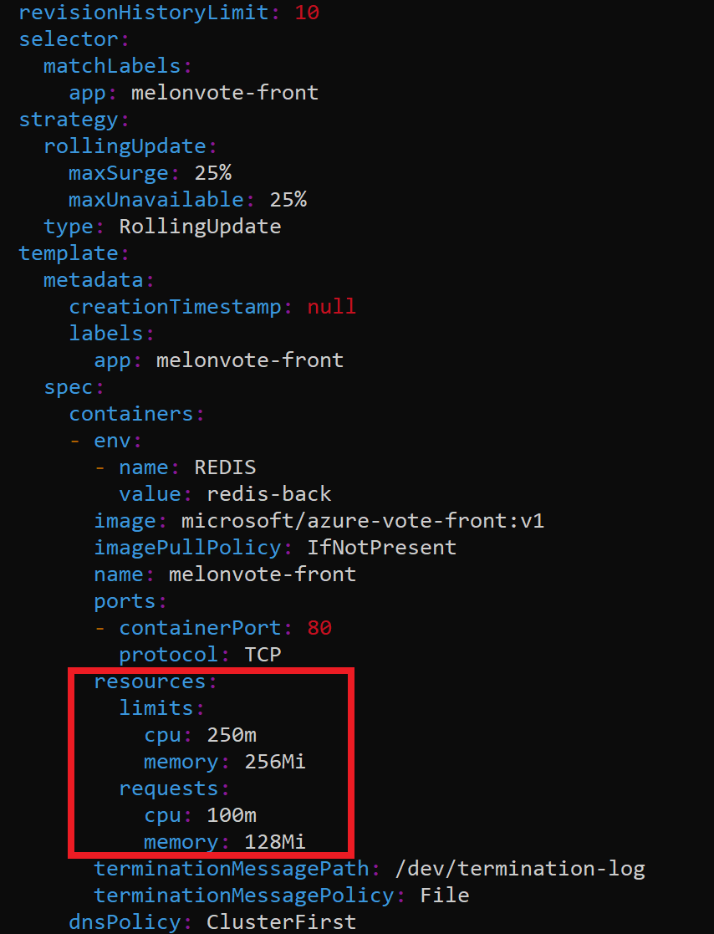

**Figure 3.21: Using the kubectl edit command to check a specific Deployment**

Now, you can edit the resource **requests** and **limits** section, as highlighted in the preceding image.

1. Update the resource **limits** and **requests** with the following values:

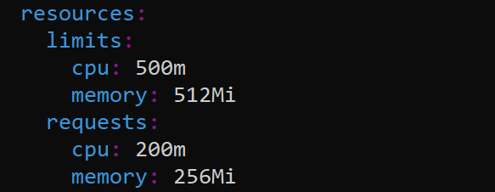

**Figure 3.22: Editing the Deployment**

1. Save and quit your text editor after making these changes. You should see an

output similar to the following:

deployment.extensions/melonvote-front edited

1. Copy the URL shown in *Figure 3.19* and paste it into the address bar of your web browser. You'll be able to test your application by checking the voting app:

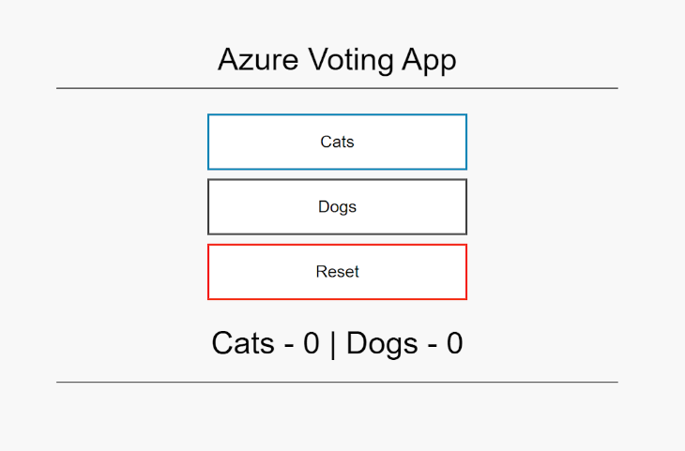

**Figure 3.23: UI of the voting app**

# CHAPTER 4: HOW TO COMMUNICATE WITH KUBERNETES (API SERVER)

## ACTIVITY 4.01: CREATING A DEPLOYMENT USING A SERVICEACCOUNT IDENTITY

### Solution:

First, we will need to create the namespace, the service principle, and the RoleBinding. For that, we will need to use our current credentials that were created by Minikube as it has the cluster admin permissions:

* 1. Create the namespace:

kubectl create namespace activity-example

You should get the following response:

namespace/activity-example created

* 1. Create a ServiceAccount in the **activity-example** namespace:

kubectl create serviceaccount activity-sa -n activity-example

You should get the following response:

serviceacoount/activity-sa created

* 1. Create a RoleBinding for the ServiceAccount and assign it a cluster

admin ClusterRole:

kubectl create rolebinding activity-sa-clusteradmin \

--clusterrole=cluster-admin \

--serviceaccount=activity-example:activity-sa \

--namespace=activity-example

You should get the following response:

rolebinding.rbac.authorization.k8s.io/activity-sa-clusteradm in created

* 1. For our curl command to work, we will need the ServiceAccount token and the CA certificate. We can get the ServiceAccount token and the certificate from the Secret associated with the ServiceAccount:

kubectl get secrets -n activity-example



**Figure 4.60: Getting a list of secrets**

Notice how the name of the Secret starts with the same name as the ServiceAccount. In this case, it is **activity-sa-token-jsmtr**.

* 1. We can check the content of this secret by displaying the output in YAML form:

kubectl get secret activity-sa-token-jzdkv -n activity-example -o yaml

In this command, use the name of the ServiceAccount obtained from the previous step. We are interested in the values of **ca.cert** and **token** in the following output:

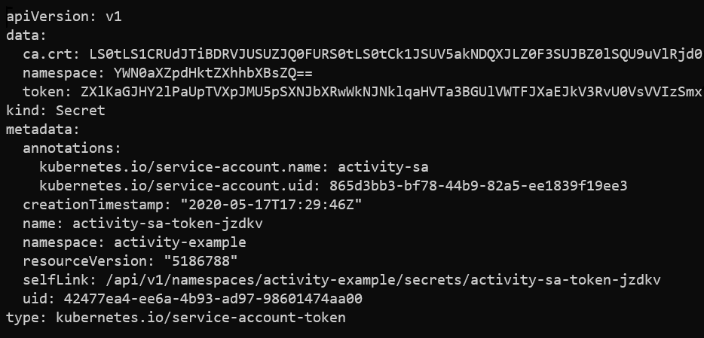

**Figure 4.61: Checking the content of the secret**

However, those values are Base64-encoded. In order to use it in our curl command, we will need to decode it. We can use the Base64 tool, which is installed by default on most Linux distributions and macOS.

* 1. To decode the values of **ca.crt** and get the token from the output of the previous step, we can use the following command:

echo "<value_of_ca.crt>" | base64 --decode > ~/ca.crt

This will write the decoded value to a file named **ca.crt**.

* 1. Do the same for the value of **token**:

echo "<value_of_token>" | base64 --decode > ~/token

This will write the decoded value to a file named **token**.

* 1. We can also keep **token** and **ca.crt** stored in a variable to use them in an easier way:

CACERT=~/ca.crt TOKEN=$(cat ~/token)

* 1. So now, the only thing left is the API server endpoint, which can be taken from our kubeconfig file. We can also easily find it with **kubectl config view**:

kubectl config view -o jsonpath="{.clusters[?(@.name==\"minikube\")].

cluster.server}" ; echo

In this command, we are using **jsonpath** to get just the API server endpoint, instead of the full kubeconfig file. So, you should get the API server address similar to the following:

https://10.210.254.169:8443

Use the API server URL address that you get in your case.

* 1. Since we are creating a Deployment from YAML data, we can easily get it by

using **kubectl create** with **--dry-run=client**:

kubectl create deployment activity-nginx --image=nginx

--dry-run=client -o yaml

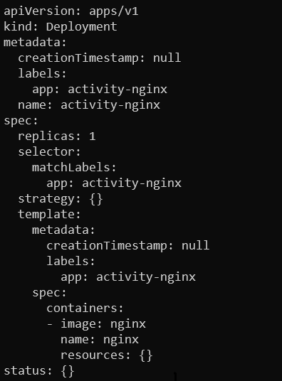

**Figure 4.62: Getting the required YAML spec using dry-run**

* 1. So, now that we have all the arguments ready, let's go ahead and create the

Deployment using our **curl** command:

curl -X POST **https://10.210.254.169:8443/apis/apps/v1/namespaces/ activity-**

**example/deployments** --cacert $CACERT -H "Authorization: Bearer $TOKEN" -H 'Content-Type: application/yaml' --data '

apiVersion: apps/v1 kind: Deployment metadata:

creationTimestamp: null labels:

run: activity-nginx name: activity-nginx

spec:

replicas: 1 selector:

matchLabels:

run: activity-nginx strategy: {}

template: metadata:

creationTimestamp: null labels:

run: activity-nginx spec:

containers:

- image: nginx

name: activity-nginx resources: {}

status: {} '

You should get a response that begins something like the following:

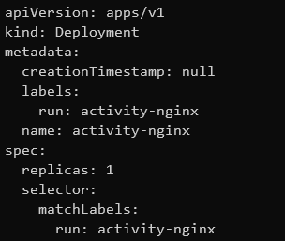

**Figure 4.63: Creating the activity-nginx Deployment**

Note that this is a truncated version of the output screenshot. You will get a much larger version.

* 1. So, now that we have created our Deployment, we can move on to the next requirement to list the pods in our Deployment and confirm that they are in a running state from the status conditions:

curl -X GET https://10.210.254.169:8443/api/v1/namespaces/activity-

example/pods --cacert $CACERT -H "Authorization: Bearer $TOKEN"

You should get the following result:

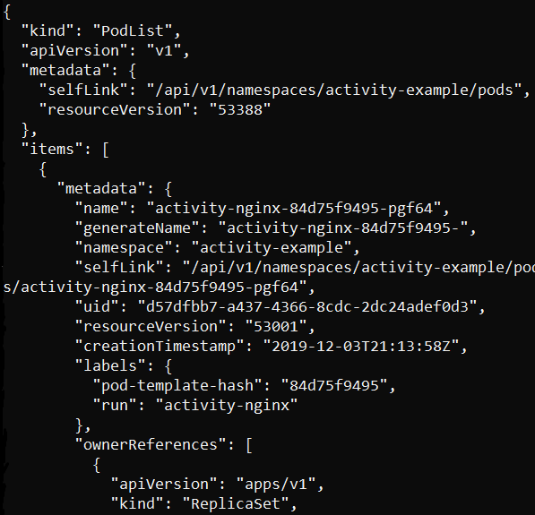

**Figure 4.64: A list of pods in JSON**

* 1. Finally, we can remove our activity namespace with the following code:

curl -X DELETE https://10.210.254.169:8443/api/v1/namespaces/

activity-example --cacert $CACERT -H "Authorization: Bearer $TOKEN"

You should get the following response:

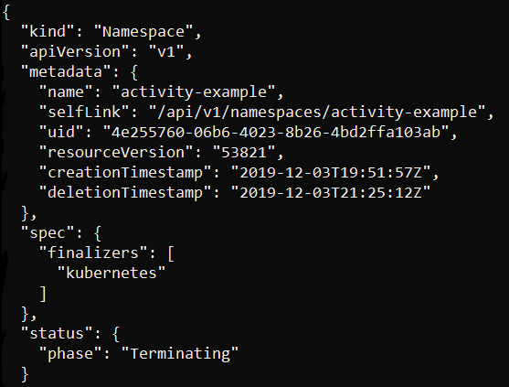

**Figure 4.65: Deleting the activity-example namespace**

You can see in the **status** section that the namespace is in the **Terminating**

phase. So, it is being deleted.

# CHAPTER 5: PODS

## ACTIVITY 5.01: DEPLOYING AN APPLICATION IN A POD

### Solution:

1. Run the following command to create a new **pods-activity** namespace:

kubectl create namespace pods-activity

You should see the following response:

namespace/pods-activity created

1. Create **activity-pod-configuration.yaml** with the following

pod configuration:

apiVersion: v1 kind: Pod metadata:

name: application-pod namespace: pods-activity

spec:

restartPolicy: OnFailure containers:

* name: custom-application-container

image: **fenago/the-kubernetes**-workshop:custom- application-for-pods-chapter

readinessProbe: exec:

command:

* + cat
  + /tmp/healthy initialDelaySeconds: 20

periodSeconds: 10

Chapter 5: Pods | 29

1. Run the following command to create the pod using

**activity-pod-configuration.yaml**:

kubectl create -f activity-pod-configuration.yaml

You should see the following response:

pod/application-pod created

1. Now, let's run the following commands to monitor how the pod is working:

kubectl --namespace pods-activity get pod application-pod

You should see the following response:

|  |  |  |  |  |
| --- | --- | --- | --- | --- |
| NAME | READY | STATUS | RESTARTS | AGE |
| application-pod | 0/1 | Running | 0 | 15s |

1. We can see that the pod has been created and is in the **Running** state. However, it's not **READY** yet. Let's wait for a few seconds and run the same command again:

kubectl --namespace pods-activity get pod application-pod

You should see the following response:

|  |  |  |  |  |
| --- | --- | --- | --- | --- |
| NAME | READY | STATUS | RESTARTS | AGE |
| application-pod | 1/1 | Running | 0 | 37s |

Now we can see that the pod is running.

# CHAPTER 6: LABELS AND ANNOTATIONS

## ACTIVITY 6.01: CREATING PODS WITH LABELS/ANNOTATIONS AND GROUPING THEM AS PER GIVEN CRITERIA

### Solution:

1. Run the following command to create a new **namespace** called

**metadata activity**:

$ kubectl create namespace metadata-activity

You should see the following response:

namespace/metadata-activity created

1. Next, we need to write pod configurations for all three pods as per the **metadata** requirements. We will handle this in three steps. First, create a file called **arbitrary-product-application.yaml** with the following content:

apiVersion: v1 kind: Pod **metadata:**

**name: arbitrary-product-application namespace: metadata-activity labels:**

**environment: production team: product-development critical: "false"**

**annotations:**

**team-link: "https://jira-link/team-link-1"**

spec:

containers:

- name: application-container image: nginx

As you can see in the highlighted section of the pod definition, we have created labels to mark the environment, team, and whether or not a pod is critical. The annotation is just a hypothetical link.

1. Create another file called **infra-libraries-application.yaml** with the following content:

apiVersion: v1 kind: Pod **metadata:**

**name: infra-libraries-application namespace: metadata-activity labels:**

**environment: production team: infra-libraries critical: "true"**

**annotations:**

**team-link: "https://jira-link/team-link-2"**

spec:

containers:

- name: application-container image: nginx

1. Create a third file called **infra-libraries-application-staging.yaml**

with the following content:

apiVersion: v1 kind: Pod **metadata:**

**name: infra-libraries-application-staging namespace: metadata-activity**

**labels:**

**environment: staging team: infra-libraries**

**annotations:**

**team-link: "https://jira-link/team-link-2"**

spec:

containers:

- name: application-container image: nginx

1. Now, we need to create all three pods. First, create the **arbitrary-product- application** pod using the following command:

$ kubectl create -f arbitrary-product-application.yaml

You should see the following response:

pod/arbitrary-product-application created

1. Now, create the **infra-libraries-application.yaml** pod:

$ kubectl create -f infra-libraries-application.yaml

You should see the following response:

pod/infra-libraries-application created

1. Finally, create the **infra-libraries-application-staging.yaml** pod:

$ kubectl create -f infra-libraries-application-staging.yaml

You should see the following response:

pod/infra-libraries-application-staging created

1. Run the following command to verify that all the pods have been created with the correct metadata:

$ kubectl --namespace metadata-activity describe pod arbitrary- product-application

You should see the following response:

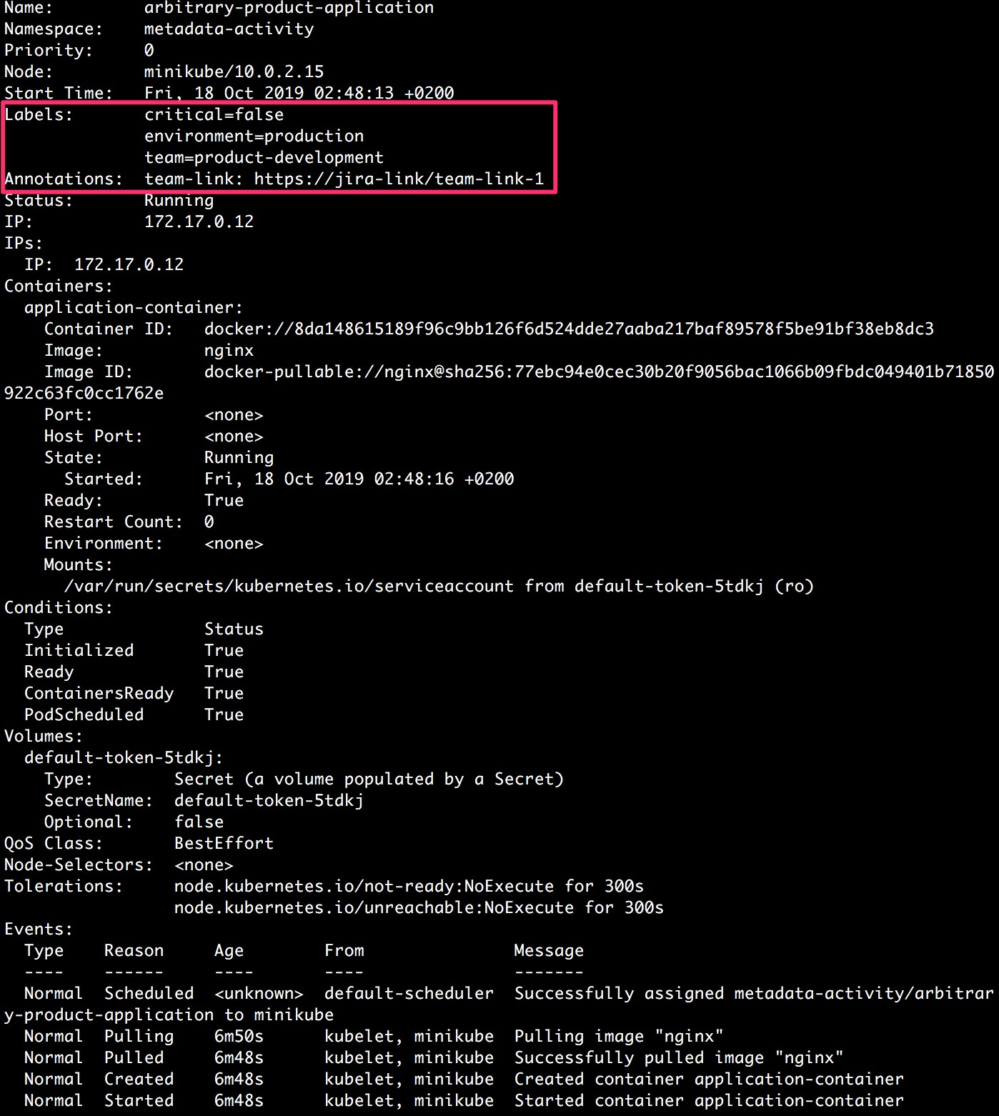

**Figure 6.20: Describing the arbitrary-product-application pod**

In the highlighted section of the output, we can see that the metadata has been added as required. For the other two pods as well, you can similarly verify the metadata.

1. Run the following command to group all the pods that run in a production environment and are critical:

|  |  |  |
| --- | --- | --- |
| $ kubectl --namespace metadata-activity get pods 'environment=production,critical=true' | -l |  |
| You should see the following list of pods: |  |  |
| NAME READY STATUS | RESTARTS | AGE |
| infra-libraries-application 1/1 Running | 0 | 12m |

1. Run the following command to group all the pods that are not critical among all environments:

$ kubectl --namespace metadata-activity get pods -l 'critical!=true'

You should see the following list of pods:

NAME READY

arbitrary-product-application 1/1 infra-libraries-application-staging 1/1

STATUS

Running Running

RESTARTS AGE

0

0

14m

14m

# CHAPTER 7: KUBERNETES CONTROLLERS

## ACTIVITY 7.01: CREATING A DEPLOYMENT RUNNING AN APPLICATION

### Solution:

* 1. Run the following command to create a new namespace called

**metadata-activity**:

kubectl create namespace controllers-activity

You should see the following response:

namespace/controllers-activity created

* 1. Create an **activity-deployment.yaml** file with the following content:

apiVersion: apps/v1 kind: Deployment metadata:

name: activity-deployment namespace: controllers-activity labels:

app: nginx spec:

replicas: 6 strategy:

type: RollingUpdate rollingUpdate:

maxUnavailable: "50%"

maxSurge: "50%" selector:

matchLabels:

chapter: controllers

activity: first

template: metadata:

labels:

chapter: controllers

activity: first

spec:

containers:

- name: nginx-container image: nginx

* 1. Create the Deployment using the **kubectl apply** command because we want to change the Deployment later:

kubectl apply -f activity-deployment.yaml

You should see the following response:

deployment.apps/activity-deployment created

* 1. Run the following command to verify that the Deployment has actually created six replicas of the Pod:

kubectl --namespace controllers-activity get pods

You should see output similar to the following:

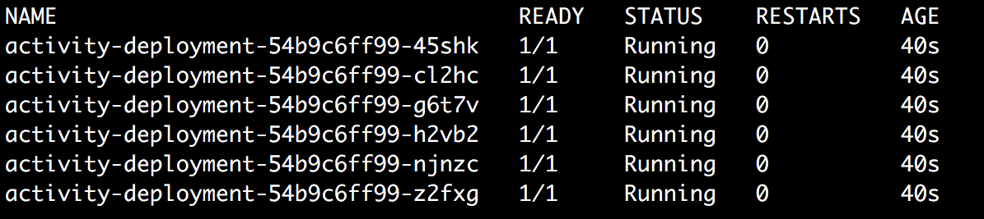

**Figure 7.15: Six Pods have been created**

* 1. Modify the content of the **activity-deployment.yaml** file to change the **replicas** field to **10** and apply the new configuration using the following command:

kubectl apply -f activity-deployment.yaml

You should see the following response:

deployment.apps/activity-deployment configured

* 1. Check the Pods to make sure that the new Pods have been created as expected:

kubectl --namespace controllers-activity get pods

You should see output similar to the following:

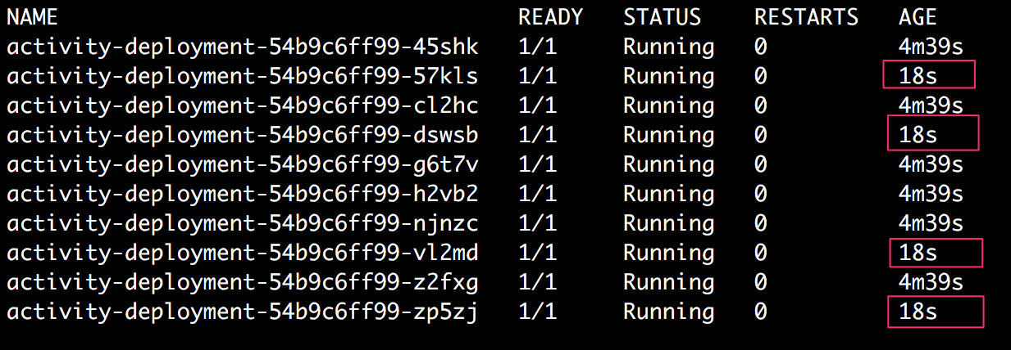

**Figure 7.16: Four new Pods have been created by the Deployment**

As highlighted in the output shown in this screenshot, we can see that 4 of the 10 Pods were created later on when we scaled up the number of replicas from **6** to **10**.

* 1. For the next step, modify the content of the **activity-deployment.yaml** file to change the **replicas** field to **5** and apply the new configuration using the following command:

kubectl apply -f activity-deployment.yaml

You should see the following response:

deployment.apps/activity-deployment configured

* 1. Check the Pods to make sure that the new Pods have been created as expected:

kubectl --namespace controllers-activity get pods

You should see the following output:

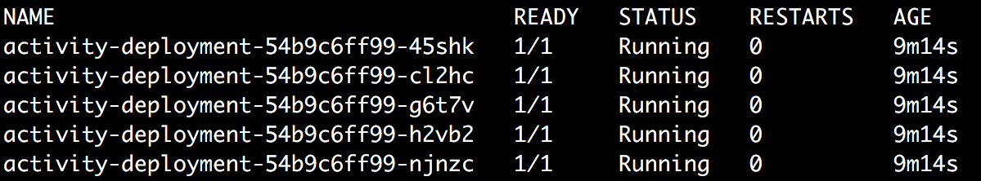

**Figure 7.17: Only five pods are running now**

As we can see in this output, the Deployment has been successfully scaled down from 10 to 5 replicas.

# CHAPTER 8: SERVICE DISCOVERY

## ACTIVITY 8.01: CREATING A SERVICE TO EXPOSE THE APPLICATION RUNNING ON A POD

### Solution:

Follow these steps to complete the solution for this activity:

1. Run the following command to create a new namespace called

**services-activity**:

kubectl create namespace services-activity

You should see the following response:

namespace/services-activity created

1. Create a file named **backend-application.yaml** with the following content:

apiVersion: apps/v1 kind: Deployment metadata:

name: backend-application namespace: services-activity labels:

application: backend spec:

replicas: 4 strategy:

type: Recreate selector:

matchLabels: application: backend

template: metadata:

labels:

application: backend spec:

containers:

- name: nginx-container image: nginx

1. Create the Deployment using the **kubectl create** command:

kubectl create -f backend-application.yaml

You should see the following response:

deployment.apps/backend-application created

1. Run the following command to verify that four Pods have been created for the backend application:

kubectl --namespace services-activity get pods

You should see the following response:

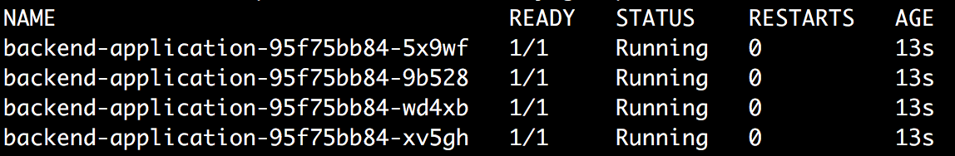

**Figure 8.19: Getting all the Pods**

1. Create a file named **backend-service.yaml** with the following content:

apiVersion: v1 kind: Service metadata:

name: backend-service namespace: services-activity

spec:

type: ClusterIP ports:

- targetPort: 80

port: 80 selector:

application: backend

1. Run the following command to create the backend Service:

kubectl create -f backend-service.yaml

You should see the following response:

service/backend-service created

1. Run the following command to check the cluster IP of the Service:

kubectl --namespace services-activity get service backend-service

You should see the following response:



**Figure 8.20: Getting the Cluster IP from the Service**

1. Let's make sure we can access the backend Service from inside the cluster:

minikube ssh

curl 10.99.220.18

You should get the following output:

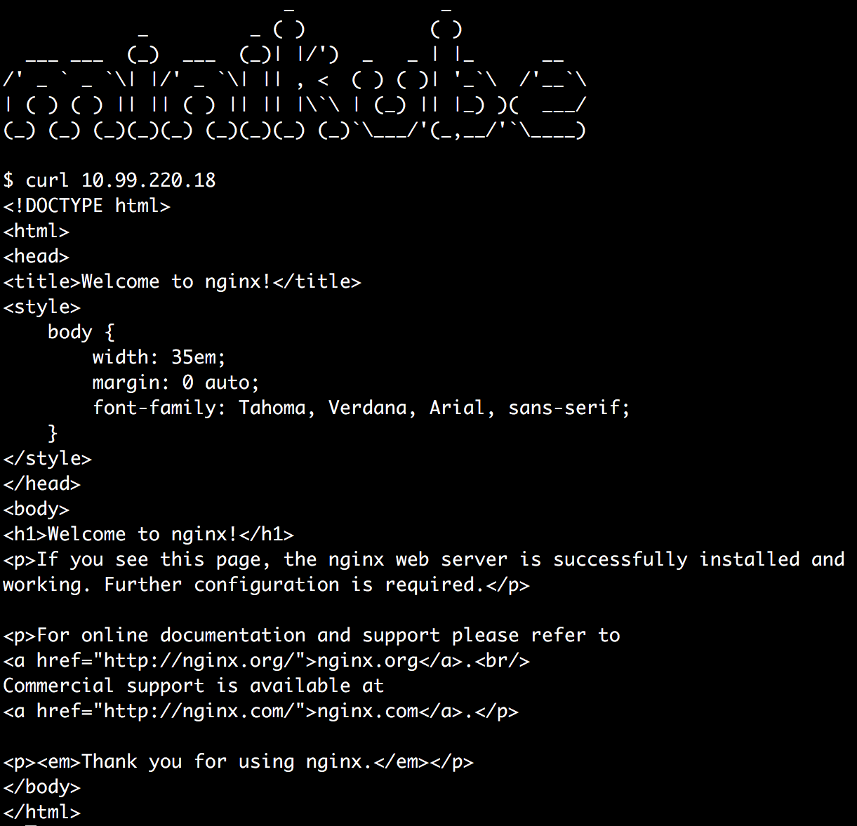

**Figure 8.21: Sending a curl request from inside the cluster**

Now, we know that the backend application has been exposed at IP address **10.99.220.18** and port number **80** inside the cluster. We will use this information to add environment variables to the frontend application Pods.

1. Run the following command to exit the SSH session inside minikube:

exit

1. Create a file named **frontend-application.yaml** with the following content:

apiVersion: apps/v1 kind: Deployment metadata:

name: frontend-application namespace: services-activity labels:

application: frontend spec:

replicas: 5 strategy:

type: Recreate selector:

matchLabels: application: frontend

template: metadata:

labels:

application: frontend spec:

containers:

* name: apache-container image: httpd:2.4

env:

* + name: BACKEND_SERVICE_IP

value: "10.99.220.18"

* + name: BACKEND_SERVICE_PORT

value: "80"

1. Run the following command to create the frontend application Deployment:

kubectl create -f frontend-application.yaml

You should get the following response:

deployment.apps/frontend-application created

1. Run the following command to verify that five of the frontend application Pods

have been created:

kubectl --namespace services-activity get pods

You should get the following response:

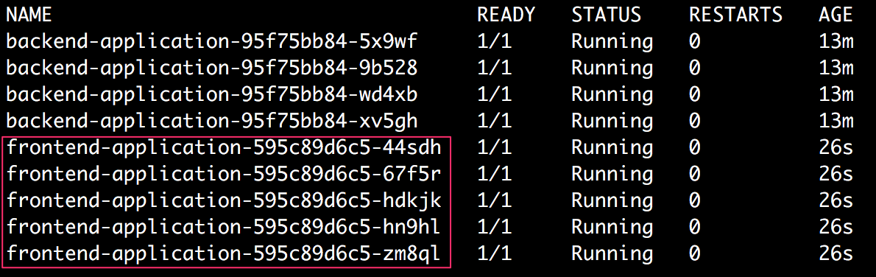

**Figure 8.22: Getting all the Pods with the frontend application as well**

Here, we can see that along with the four existing backend Pods, five new

frontend Pods have also been created.

1. Next, run the following command to verify that these Pods have the correct environment variables set:

kubectl --namespace services-activity describe pod frontend-

application-595c89d6c5-hn9hl

Pick any of the frontend application's Pod names from the output of the previous step.

You should get the following response:

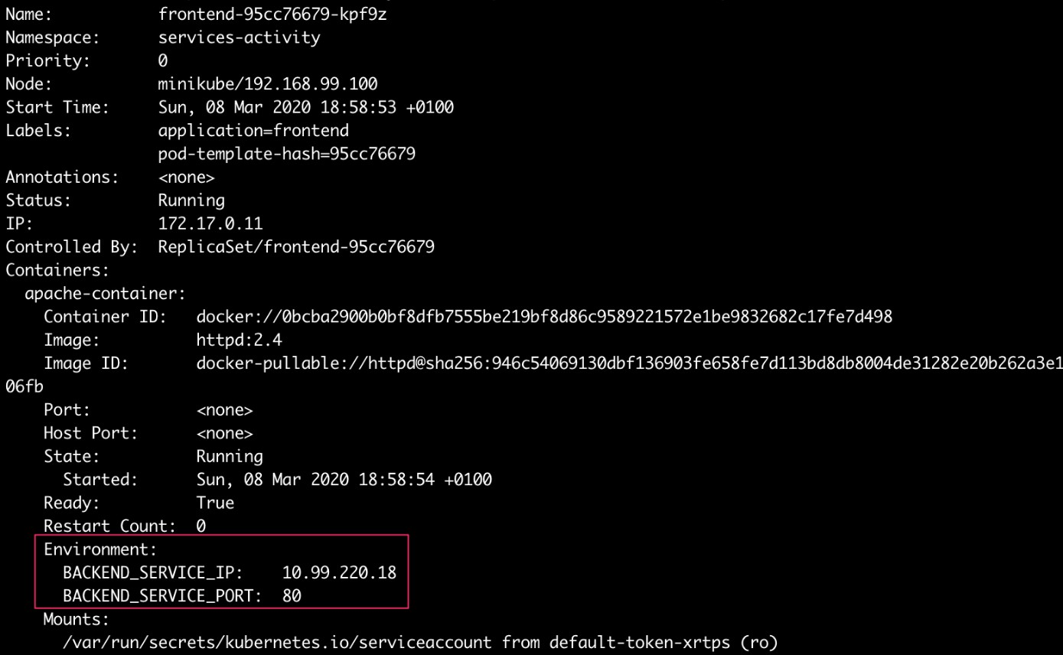

**Figure 8.23: Verifying the environment variables**

In the highlighted section of the preceding output, we can see that the two environment variables, **BACKEND_SERVICE_IP** and **BACKEND_SERVICE_ PORT**, have the desired values.

1. Next, create a file named **frontend-service.yaml** with the following content:

apiVersion: v1 kind: Service metadata:

name: frontend-service namespace: services-activity

spec:

type: NodePort ports:

- port: 80

targetPort: 80

nodePort: 31000

selector:

application: frontend

1. Run the following command to create the frontend Service:

kubectl create -f frontend-service.yaml

You should get the following response:

service/frontend-service created

1. Run the following command to check the status of the Service:

kubectl --namespace services-activity get service frontend-service

You should get the following response:



**Figure 8.24: Verifying that the NodePort Service has been created**

1. Next, we need to verify that the frontend service is accessible from outside the Kubernetes cluster. For that, we need to know the IP address of the host. Run the following command to find out the IP address of the minikube host:

minikube ip

You should get the following output:

192.168.99.100

1. Run the following command using **curl** to access the frontend application:

curl 192.168.99.100:31000

You should see the following output:

<html><body><h1>It works!</h1></body></html>

1. We can also enter the same address in a browser's address bar to see the following output:



**Figure 8.25: Verifying the frontend application in the browser**

# CHAPTER 9: STORING AND READING DATA ON DISK

## ACTIVITY 9.01: CREATING A POD THAT USES A DYNAMICALLY PROVISIONED PERSISTENTVOLUME

### Solution:

* 1. Run the following command to create a new namespace, **volumes-activity**:

kubectl create namespace volumes-activity

You should see the following output:

namespace/volumes-activity created

This output indicates that the namespace was successfully created.

* 1. Create a file called **sc-activity-local.yaml** with the following content:

apiVersion: storage.k8s.io/v1 kind: StorageClass

metadata:

name: activity-local

provisioner: k8s.io/minikube-hostpath

In this configuration for **StorageClass**, we have used the local

**k8s.io/minikube-hostpath** provisioner that comes with minikube.

* 1. Run the following command to create the storage class using the

preceding configuration:

kubectl create -f sc-activity-local.yaml

Note that we haven't used a **--namespace** flag when creating the storage class. That's because the storage classes are cluster-scoped. So, this storage class will be visible to all namespaces.

You should see the following output:

storageclass.storage.k8s.io/activity-local created

* 1. Run the following command to check the status of the newly created storage class:

kubectl get sc activity-local

Note that **sc** is an accepted shortened name for **StorageClass**. You should see the following output:

|  |  |  |
| --- | --- | --- |
| NAME | PROVISIONER | AGE |
| activity-local | k8s.io/minikube-hostpath | 11s |

* 1. Next, let's create a file called **pvc-activity-local-claim.yaml** with the following content:

apiVersion: v1

kind: PersistentVolumeClaim metadata:

name: activity-local-claim namespace: volumes-activity

spec:

storageClassName: activity-local accessModes:

- ReadWriteOnce resources:

requests: storage: 100Mi

In this configuration, we have specified the storage class name to be

**activity-local**, which is the storage class we created in the last step.

* 1. Run the following command to create a PVC using the preceding configuration:

kubectl create -f pvc-activity-local-claim.yaml

You should see the following output:

persistentvoumeclaim/activity-local-claim created

* 1. Run the following command to check the status of the claim we just created:

kubectl --namespace volumes-activity get pvc activity-local-claim

You should see the following output:



**Figure 9.14: Checking the status of the PVC**

We can see that the PVC is bound to a Volume that was dynamically created.

* 1. Run the following command to check the list of PVs in this namespace:

kubectl --namespace volumes-activity get pv

You should see the following output:



**Figure 9.15: Checking the list of PVs**

We can see that we have a PV that has an **activity-local** storage class and is bound to the **activity-local-claim** claim.

* 1. Next, create a file called **activity-pod.yaml** with the following content:

apiVersion: v1 kind: Pod metadata:

name: activity-pod namespace: volumes-activity

spec:

containers:

- image: ubuntu name: ubuntu-1

command: ['/bin/bash', '-ec', 'echo "Data written by container-1"

* /data/application/data.txt; sleep 3600'] volumeMounts:

- mountPath: /data/application name: pvc-volume

* + image: ubuntu name: ubuntu-2

command: ['/bin/bash', '-ec', 'sleep 30; cat /data/application/ data.txt; sleep 3600']

volumeMounts:

- mountPath: /data/application name: pvc-volume

volumes:

* + name: pvc-volume persistentVolumeClaim:

claimName: activity-local-claim

As we can see, we have used the claim named **activity-local-claim** as the volume and mounted it on both the containers at **/data/application**. The first container writes some data to a file in the PV and the second container waits for 30 seconds and then reads out the content of the file written by

the former container. Both of the containers then sleep for 1 hour. This is an

optional configuration. We can also skip the sleeping step at the end.

* 1. Run the following command to create the pod using the

preceding configuration:

kubectl create -f activity-pod.yaml

You should see the following output:

pod/activity-pod created

* 1. Run the following command to get the status of the pod we just created to

confirm that it is still running:

kubectl --namespace volumes-activity get pod activity-pod

You should see the following output:

|  |  |  |  |  |
| --- | --- | --- | --- | --- |
| NAME | READY | STATUS | RESTARTS | AGE |
| activity-pod | 2/2 | Running | 0 | 12s |

* 1. Next, let's wait for at least 30 seconds and then check the logs of the **ubuntu-2**

container on the pod:

kubectl --namespace volumes-activity logs activity-pod -c ubuntu-2

You should see the following output:

Data written by container-1

This output verifies that the **ubuntu-2** container can read the data written by the **ubuntu-1** container in the PV directory.

# CHAPTER 10: CONFIGMAPS AND SECRETS

## ACTIVITY 10.01: USING A CONFIGMAP AND SECRET TO PROMOTE AN APPLICATION THROUGH DIFFERENT STAGES

### Solution:

First, we will create objects in the **my-app-test** namespace, as shown in the following steps:

* + 1. First, create the test namespace:

kubectl create namespace my-app-test

You should get a response like this:

namespace/my-app-test created

* + 1. Create a folder for the test namespace:

mkdir -p activity-configmap-secret/test cd activity-configmap-secret/test

* + 1. Create the **application-data.properties** file. You can use any text editor to create this file:

external-system-location=https://testvendor.example.com external-system-basic-auth-username=user123

* + 1. Create the ConfigMap in the test namespace using this command:

kubectl create configmap my-app-data --from-file=./application-data.

properties --namespace my-app-test

You should see the following output:

configmap/my-app-data created

* + 1. Create a file with the password, as shown here:

cat > application-secure.properties << EOF external-system-basic-auth-password=password123 EOF

* + 1. Create a Secret in the test namespace using the following command:

kubectl create secret generic my-app-secret --from-file=application-

secure.properties --namespace my-app-test

You should see a response like this:

secret/my-app-secret created

* + 1. Create a YAML file named **activity-solution-pod-spec.yaml** with the following content:

apiVersion: v1 kind: Pod metadata:

name: configmap-secrets-activity-pod

spec:

containers:

* name: configmap-secrets-activity-container

image: k8s.gcr.io/busybox

command: [ «/bin/sh", "-c", "cat /etc/app- data/application-data.properties; cat /etc/secure-

data/application-secure.properties;" ] volumeMounts:

* + name: config-volume

mountPath: /etc/app-data

* + name: secret-volume mountPath: /etc/secure-data

volumes:

* name: config-volume configMap:

name: my-app-data

* name: secret-volume secret:

secretName: my-app-secret

* + 1. Run the Pod using the YAML specification in the previous step. It should load both the ConfigMap and Secret onto the Pod:

kubectl create -f activity-solution-pod-spec.yaml --namespace my-app- test

When the Pod is successfully created, you should see a response like this:

pod/configmap-secrets-activity-pod created

* + 1. View the logs to see whether the required data is loaded onto the Pod:

kubectl logs -f configmap-secrets-activity-pod --namespace my-app-test

The logs should show the username and password, as shown in this output:

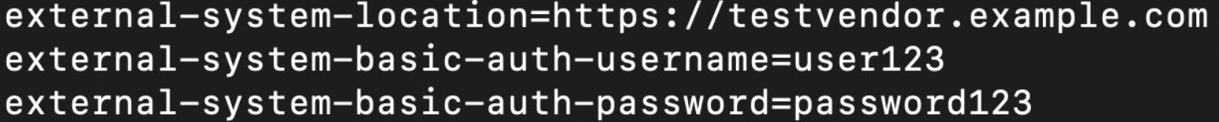

**Figure 10.20: Getting logs for the test environment**

* + 1. Next, we will create objects in the **my-app-prod** namespace, as mentioned in the following steps. First, create the test namespace:

kubectl create namespace my-app-prod

You should see an output like this:

namespace/my-app-prod created

* + 1. Create a folder for the **prod** namespace using the following commands:

mkdir -p activity-configmap-secret/prod cd activity-configmap-secret/prod

* + 1. Create the **application-data.properties** file with the required data:

cat > application-data.properties << EOF

external-system-location=https://vendor.example.com external-system-basic-auth-username=activityapplicationuser EOF

* + 1. Create a ConfigMap in the **my-app-prod** namespace, as follows:

kubectl create configmap my-app-data --from-file=./application-data.

properties --namespace my-app-prod

You should expect the following response:

configmap/my-app-data created

* + 1. Create the file that contains the password using the following command:

cat > application-secure.properties << EOF

external-system-basic-auth-password=A#4b*(1=B88%tFr3 EOF

* + 1. Create a Secret in the **my-app-prod** namespace:

kubectl create secret generic my-app-secret --from-file=application-

secure.properties --namespace my-app-prod

You should see a response like this:

secret/my-app-secret created

* + 1. Create and run the Pod using the following command:

kubectl create -f activity-solution-pod-spec.yaml --namespace my-app- prod

You should see an output like this:

pod/configmap-secrets-activity-pod created

* + 1. View the logs to check whether the required information is loaded onto our Pod:

kubectl logs -f configmap-secrets-activity-pod --namespace my-app-prod

You should be able to see the production configuration for the Pod,

as shown here:



**Figure 10.21: Getting logs for the production environment**

# CHAPTER 11: BUILD YOUR OWN HA CLUSTER

## ACTIVITY 11.01: TESTING THE RESILIENCE OF A HIGHLY AVAILABLE CLUSTER

### Solution:

First, please ensure that you have the cluster infrastructure set up as shown in

*Exercise 11.01*, *Setting Up Our Kubernetes Cluster*. Then, follow these steps:

* + - 1. First, let's scale the deployment to 10 replicas:

kubectl scale deployment -n kubernetes-dashboard kubernetes-dashboard

--replicas 10

You should see the following response:

deployment.extensions/kubernetes-dashboard scaled

* + - 1. Now it is bringing up more Pods. We can confirm this by using the

following command:

kubectl get pod -n kubernetes-dashboard

You should see this response:

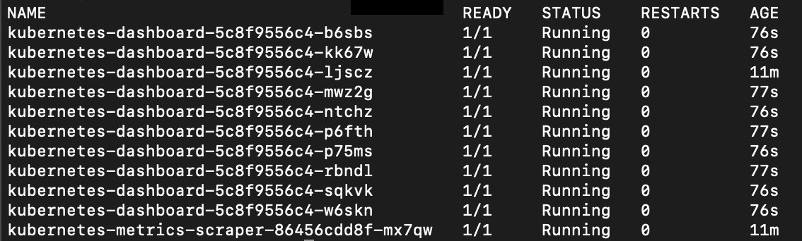

**Figure 11.16: Verifying that the number of Pods has scaled**

* + - 1. Okay, now for the fun part. Let's start deleting Pods randomly. We can do that using a script. Create a file named **delete_pods.sh** with the following content:

#!/bin/bash

while [ true ]; do

NUM=$[ ( $RANDOM % 10 ) ]

kubectl get pod -n kubernetes-dashboard | awk -v num=$NUM '(NR==num && NR > 1) {print $1}' | xargs kubectl delete pod -n

kubernetes-dashboard sleep "$NUM"s

done

This script will pick a random number between 1 and 10 and delete that Pod.

* + - 1. Now, let's run our script:

bash delete_pods.sh

You should see a response similar to this:

pod "kubernetes-dashboard-5c8f9556c4-rbndl" deleted pod "kubernetes-dashboard-5c8f9556c4-ntchz" deleted

* + - 1. Try accessing the application at the following URL:

http://localhost:8001/api/v1/namespaces/kubernetes-dashboard/ services/https:kubernetes-dashboard:/proxy/

We should still be able to get a response from our application:

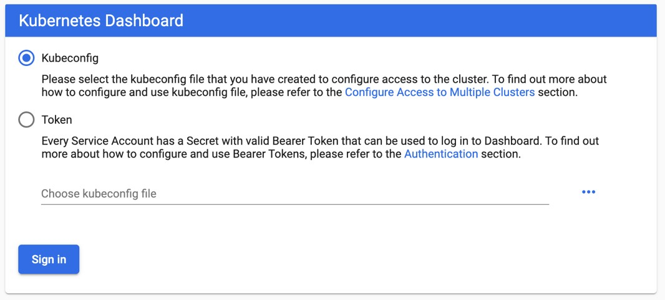

**Figure 11.17: Kubernetes Dashboard prompt for entering a token**

* + - 1. It looks like our application is still online. What happens though if we accidentally

(or on purpose) delete a node? Go to the AWS console and navigate to the

EC2 section:

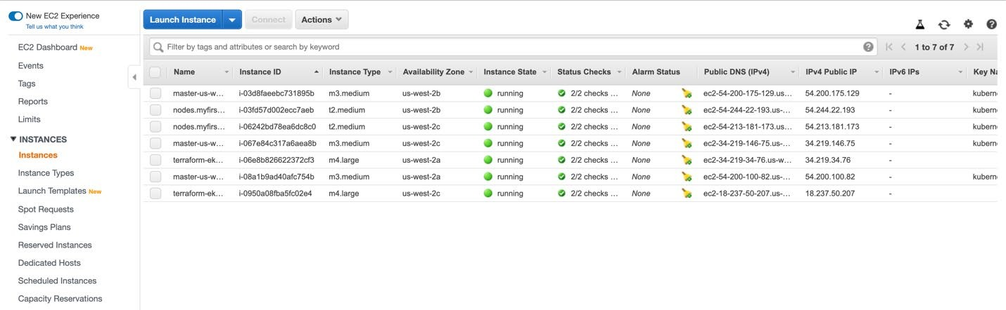

**Figure 11.18: List of EC2 instances on the AWS dashboard**

* + - 1. All of the nodes that are part of our cluster have **myfirstcluster** as part of their name. Let's pick one of these nodes and terminate it using the **Actions** menu:

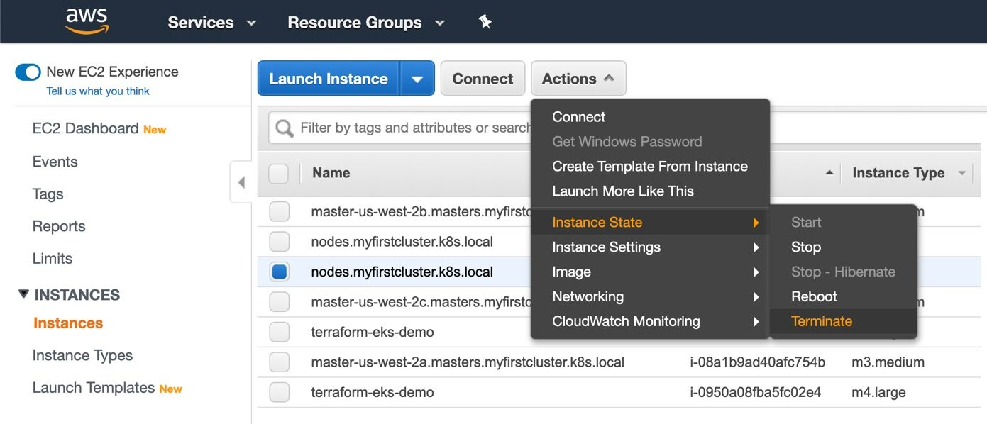

**Figure 11.19: Terminating a node**

* + - 1. Click **Yes, Terminate** to acknowledge your proposed mistake:

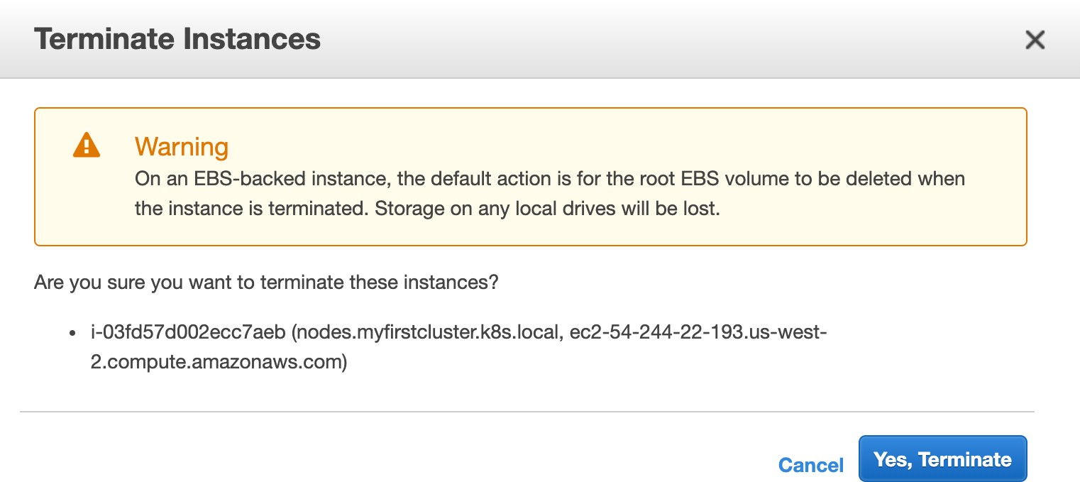

**Figure 11.20: Confirming the termination of a node**

* + - 1. Let's go check to see whether the application is online by checking the list of Pods:

kubectl get pod -n kubernetes-dashboard

You should see the following response:

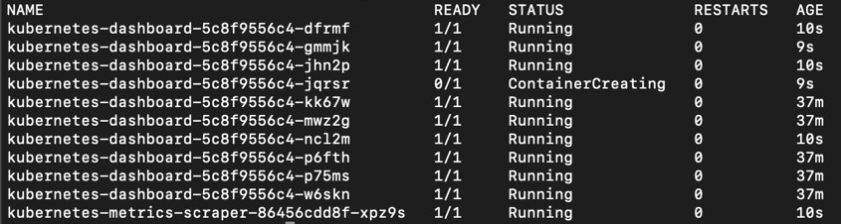

**Figure 11.21: Kubernetes Dashboard prompt for entering a token**

As you can see in the preceding screenshot, the Pods are already being restarted on nodes that are still online. In addition, the AWS Autoscaling group that kops created for us will automatically spin up a new node to replace the one we terminated.

* + - 1. Now, let's add an additional node. To do that, we need to edit InstanceGroups. First, get a list of InstanceGroups:

kops get ig

You should see a response similar to this:

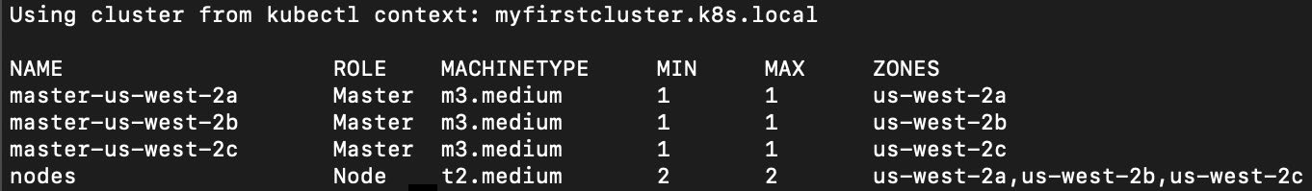

**Figure 11.22: List of instance groups**

* + - 1. We want to edit the **nodes** instance group. Run the following command:

kops edit ig nodes

This will open up the spec of the instance group in a text editor, as shown in the following screenshot:

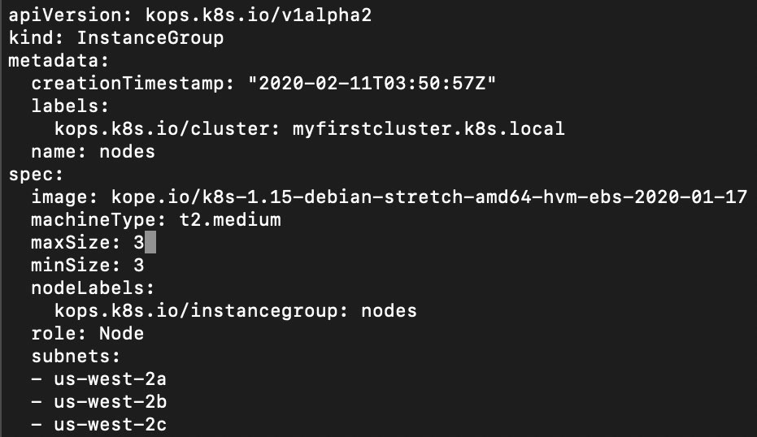

**Figure 11.23: List of instance groups**

In this spec, change the value of **maxSize** and **minSize** to **3** and then save it.

* + - 1. To apply this change, run the following command:

kops update cluster --yes

You should see this response:

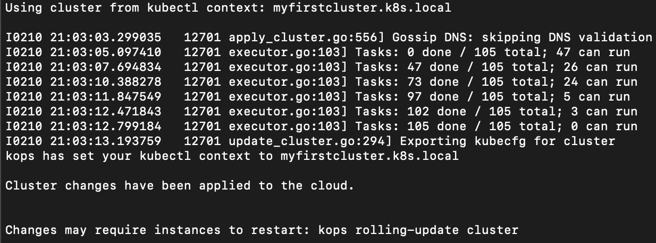

**Figure 11.24: Applying updates to our cluster**

* + - 1. In the previous screenshot, you can see that kops suggests that we restart the cluster, which is done in the form of a rolling update. This is not an absolute necessity for our scenario. You will learn more about rolling updates in *Chapter 18*, *Upgrading Your Cluster without Downtime*. For now, you can simply run the **rolling-update** command:

kops rolling-update cluster --yes

You should see output similar to this:

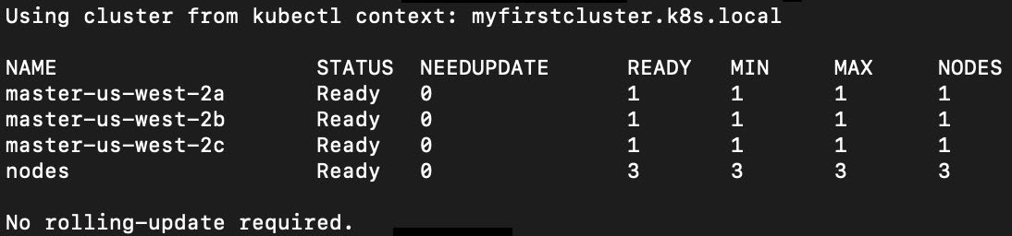

**Figure 11.25: Applying rolling-update to our cluster**

From the output, we can see that we have three nodes up and running in our cluster.

# CHAPTER 12: YOUR APPLICATION AND HA

## ACTIVITY 12.01: EXPANDING THE STATE MANAGEMENT OF OUR APPLICATION

### Solution:

Before starting these steps, make sure you have run through *Exercise 12.04*, *Deploying an Application with State Management* and still have all the resources from that exercise. We need to modify a few files in order to get this solution to work:

* + - * 1. We need to add the following to the **main.tf** Terraform file that we used to

spin up the cluster:

resource "aws_security_group" "redis_sg" { name = "redis-sg"

vpc_id = aws_vpc.demo.id ingress {

from_port = 6379 protocol = "TCP" to_port = 6379

security_groups = [aws_security_group.demo-node.id]

}

}

resource "aws_elasticache_subnet_group" "redis_subnet" { name = "redis-cluster-subnet-group"

subnet_ids = aws_subnet.demo.*.id

}

resource "aws_elasticache_cluster" "redis_cluster" { cluster_id = "redis-cluster"

engine = "redis"

node_type = "cache.m4.large" num_cache_nodes = 1

parameter_group_name = "default.redis3.2" engine_version = "3.2.10"

port = 6379

security_group_ids = [aws_security_group.redis_sg.id] subnet_group_name = aws_elasticache_subnet_group.redis_subnet.name

}

output "redis_address" {

value = "${aws_elasticache_cluster.redis_cluster.cache_nodes[0].

address}:6379"

}

* + - * 1. Let's apply and approve the changes:

terraform apply

Enter the correct value of the region if prompted again. You should see the following output:

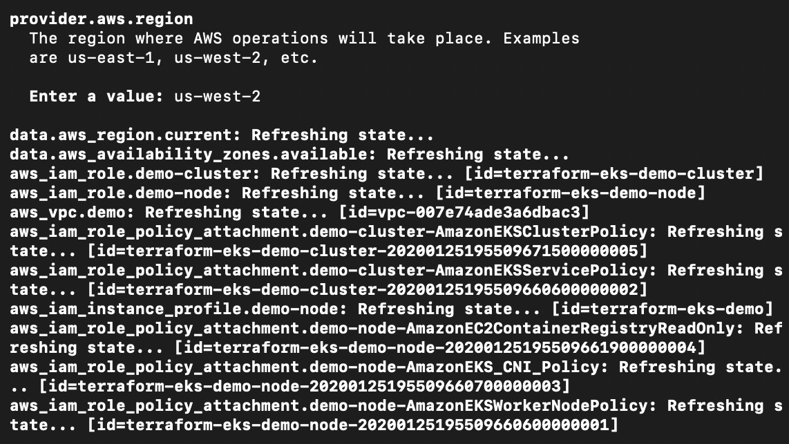

**Figure 12.21: Recreating our cluster with ElastiCache for state management**

This should add an ElastiCache Redis cluster for us to use. The previous command produces a long output. In that output, find the **redis_address** field near the end. It should look like this:



**Figure 12.22: redis_address from the Terraform output screen**

Then, we need to modify our application to connect to this instance instead of our in-cluster Redis instance.

* + - * 1. In the **containers** section of the Deployment spec of the manifest from *Exercise 12.04*, *Deploying an Application with State Management*, add an environment variable named **REDIS_SVC_ADDR** with the value that you obtained from the previous step:

env:

- name: REDIS_SVC_ADDR value: "use-your-value"

* + - * 1. Apply the changes:

kubectl apply -f with_redis_activity.yaml

You should see the following response:



**Figure 12.23: Recreating the objects for our application**

* + - * 1. Now, let's test the change:

kubectl port-forward svc/kubernetes-test-ha-application-with-redis 8080:80

You should see the following response:

Forwarding from 127.0.0.1:8080 -> 8080

* + - * 1. Now, in another terminal session, let's try accessing our application multiple times:

curl localhost:8080/get-number

You should see the number increasing, as follows:

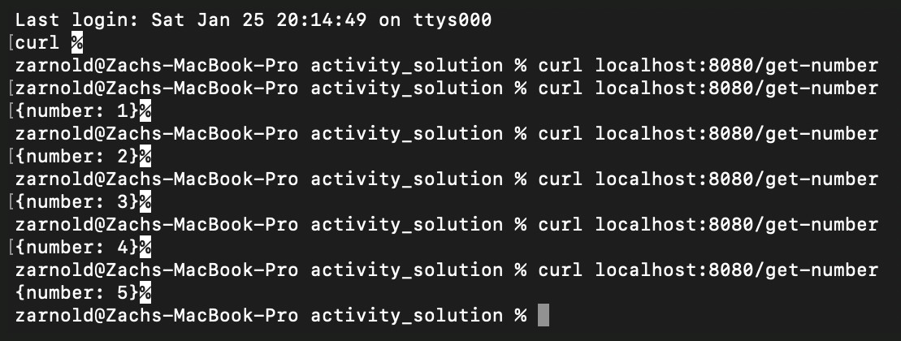

**Figure 12.24: Getting a predictable output from our application with an ElastiCache backend**

# CHAPTER 13: RUNTIME AND NETWORK SECURITY IN KUBERNETES

## ACTIVITY 13.01: SECURING OUR APP

### Solution:

In this activity, we will modify the RBAC policies from *Exercise 13.01*, *Creating a Kubernetes RBAC ClusterRole*, to allow required traffic:

1. Ensure that you have a cluster infrastructure and all the objects from

*Exercise 13.01*, *Creating a Kubernetes RBAC ClusterRole*.

1. Create a file named **pod_security_policy.yaml** with the following content:

apiVersion: policy/v1beta1 kind: PodSecurityPolicy metadata:

name: psp-example namespace: default

spec:

privileged: false seLinux:

rule: RunAsAny supplementalGroups:

rule: RunAsAny runAsUser:

rule: RunAsAny fsGroup:

rule: RunAsAny volumes:

- ‹*›

1. Now, apply this policy using the following command:

kubectl apply -f pod_security_policy.yaml

You should see the following response:

podsecuritypolicy.policy/psp-example created

Chapter 13: Runtime and Network Security in Kubernetes | 63

1. Create a file named **network_policy.yaml** with the following content:

apiVersion: networking.k8s.io/v1 kind: NetworkPolicy

metadata:

name: test-network-policy namespace: default

spec:

podSelector: {} ingress:

- {}

egress:

- {}

policyTypes:

* Ingress
* Egress

---

apiVersion: networking.k8s.io/v1 kind: NetworkPolicy

metadata:

name: test-network-policy-redis namespace: default

spec:

podSelector: {} ingress:

- {}

egress:

- {}

policyTypes:

* Ingress
* Egress

**NOTE**

There is a workaround in this file since kubectl proxy opens a different port on your machine to communicate with the cluster. Since this port is unknown ahead of time, it is set to **all**.

1. Now, apply this policy using the following command:

kubectl apply -f network_policy.yaml

You should see the following response:

networkpolicy.networking.k8s.io/test-network-policy created

1. If you have the application from *Exercise 13.02*, *Creating a NetworkPolicy* still deployed in your cluster, you can move on to the next step. Otherwise, rerun *steps 5* and *6* from that exercise.
2. Now, let's test our application:

curl localhost:8001/api/v1/namespaces/default/services/kubernetes- test-ha-application-with-redis:/proxy/get-number

You should see the following response:

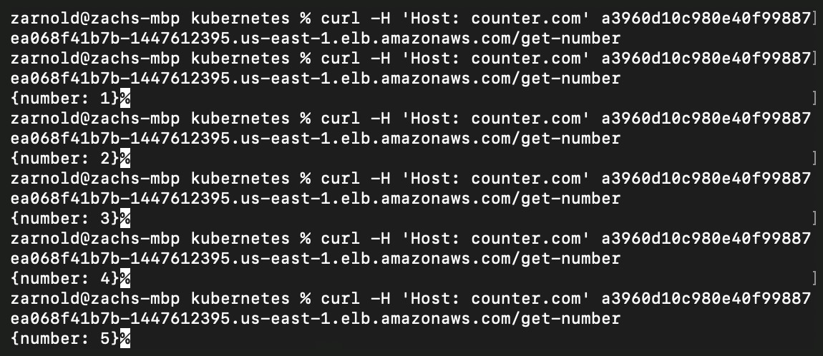

**Figure 13.15: Testing our application**

# CHAPTER 14: RUNNING STATEFUL COMPONENTS IN KUBERNETES

## ACTIVITY 14.01: CHART-IFYING OUR STATEFULSET DEPLOYMENT

### Solution:

Before you begin with these steps, please ensure that your cluster infrastructure is set up as instructed in *step 1* of *Exercise 14.01*, *Deploying a Counter App with a MySQL Backend*.

* 1. Let's start by creating the Helm chart:

helm create counter-mysql

You should see this response:

Creating counter-mysql

* 1. Next, change directory into it:

cd counter-mysql

Now let's clean up the working directory a bit here:

rm ./templates/*.yaml && rm ./templates/NOTES.txt && rm -r ./ templates/tests/

* 1. Now we need to download the **with_mysql.yaml** file from the GitHub

repository for this chapter:

curl https://raw.githubusercontent.com/PacktWorkshops/Kubernetes- Workshop/master/Chapter14/Exercise14.01/with_mysql.yaml > ./ templates/with_mysql.yaml

You should see the following response:



**Figure 14.15: Downloading the combined manifest for our application**

* 1. Now we need to split this into different files, so separate them using **---** into different files. You can name the files whatever you want; Helm will glob them together. Note that you should remove **with_mysql.yaml** after you are done copying out of it:

tree .

The following file structure gives an example of how you can split them:

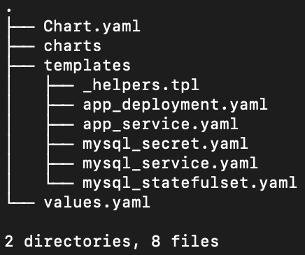

**Figure 14.16: Directory structure for our Helm chart**

* 1. Now we need to templatize our MySQL version deployment. Clear out all the

contents of **values.yaml** and replace it with the following:

mysql:

version: 5.7

* 1. Now, we should change the manifest for the MySQL StatefulSet. Let's change the **mysql_statefulset.yaml** file to take this value as an argument to the **image** field in the manifest as shown here:

spec:

containers:

- name: mysql

image: mysql:**{{ .Values.mysql.version }}**

* 1. Now let's install this chart by running the following command:

helm install --generate-name -f values.yaml .

You should see a response similar to the following:

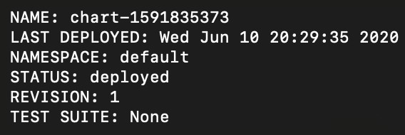

**Figure 14.17: Installing our Helm chart with a generated name**

* 1. Let's set up port forwarding so that we can access our application:

kubectl port-forward service/kubernetes-test-ha-application-with- mysql 8080:80

You should see this response:

Forwarding from 127.0.0.1:8080 -> 8080

Forwarding from [::1]:8080 -> 8080

* 1. Now, open another terminal window to access our application. Run the following command a few times:

curl localhost:8080/get-number

You should see this response:

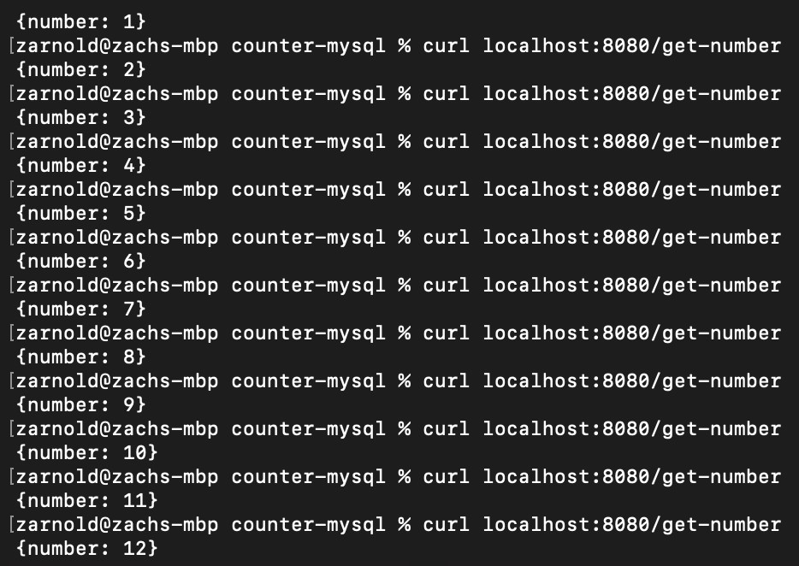

**Figure 14.18: Testing our application**

* 1. Now to clean up, let's run the following command to find out what is

currently deployed:

helm ls

You should see a response similar to the following:

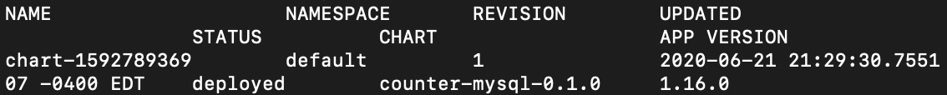

**Figure 14.19: Listing all the installed Helm charts**

From this output, you can determine the name of the chart that you need to delete for cleanup. For the author's instance, the name of the chart is **chart- 1592789369**.

* 1. Now run the following command to delete the chart, using the name for your instance:

helm uninstall chart-1592789369

You should see a response similar to the following:

release "chart-1592789369" uninstalled

* 1. Finally, because this is a StatefulSet, we need to clean up any PersistentVolumes before deleting our cluster out of AWS or we'll be paying for them for quite some time!

kubectl delete pv --all

You should see a response similar to this:

persistentvolume "pvc-b20b473b-73a9-4d9c-befc-c0be15c44011" deleted

Don't forget to clean up your cloud resources using the

**terraform destroy** command.

Chapter 15: Monitoring and Autoscaling in Kubernetes | 69

# CHAPTER 15: MONITORING AND AUTOSCALING IN KUBERNETES

## ACTIVITY 15.01: AUTOSCALING OUR CLUSTER USING CLUSTERAUTOSCALER

### Solution:

Before you begin, please make sure you have your EKS cluster set up and that you

have successfully completed all the exercises in this chapter:

* + 1. Assuming that your infrastructure is set up and you have all the required resources from the exercises in this chapter, we simply need to run another load test, but this time for much longer. Run the following command to begin the load test:

docker run --rm skandyla/wrk -t10 -c1000 -d86400 -H 'Host: counter. com' http://YOUR_HOSTNAME/get-number

Use the Ingress endpoint that you obtain in *step 5* of *Exercise 15.02*, *Scaling Workloads in Kubernetes*. Note that this may take between 15 minutes to an hour of sustained load. You should see the following output, indicating that the load test is running:

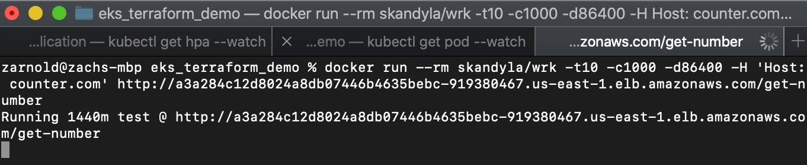

**Figure 15.34: Running the load test**

* + 1. Run the following command to observe the number of worker nodes:

kubectl get node

You should see the following response:

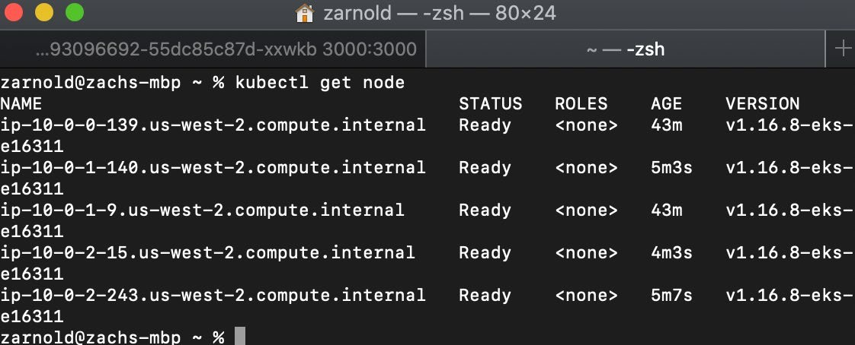

**Figure 15.35: Observing the nodes through the kubectl command**

Note that there are now five nodes running.

* + 1. At this stage, you can even observe the nodes in the Grafana dashboard:

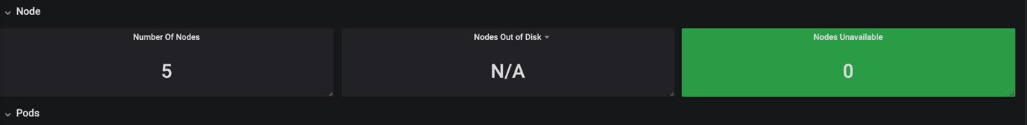

**Figure 15.36: Observing the nodes in the Grafana dashboard**

Don't forget to clean up your cloud resources using the **terraform destroy**

command to stop AWS billing you after you are done with the activity.

# CHAPTER 16: KUBERNETES ADMISSION CONTROLLERS

## ACTIVITY 16.01: CREATING A MUTATING WEBHOOK THAT ADDS AN ANNOTATION TO A POD

### Solution:

* + - 1. If you are following the exercises in the chapter, please make sure that you delete the existing **webhooks** namespace:

kubectl delete ns webhooks

You should see the following response:

namespace "webhooks" deleted

* + - 1. Create a namespace with the name **webhooks**:

kubectl create ns webhooks

You should see the following response:

namespace/webhooks created

* + - 1. Generate a self-signed certificate:

openssl req -nodes -new -x509 -keyout controller_ca.key -out controller_ca.crt -subj "/CN=Mutating Admission Controller Webhook CA"

You should see the following response:

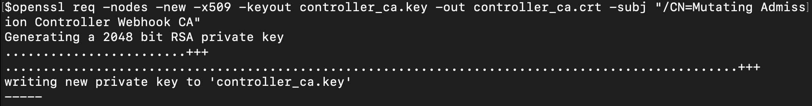

**Figure 16.19: Generating a self-signed certificate**

* + - 1. Generate a private/public key pair and sign it with a CA certificate. This can be

done with the following two commands:

openssl genrsa -out tls.key 2048

openssl req -new -key tls.key -subj "/CN=webhook-server.webhooks.svc"

\

| openssl x509 -req -CA controller_ca.crt -CAkey controller_

ca.key -CAcreateserial -out tls.crt

You will get the following response:

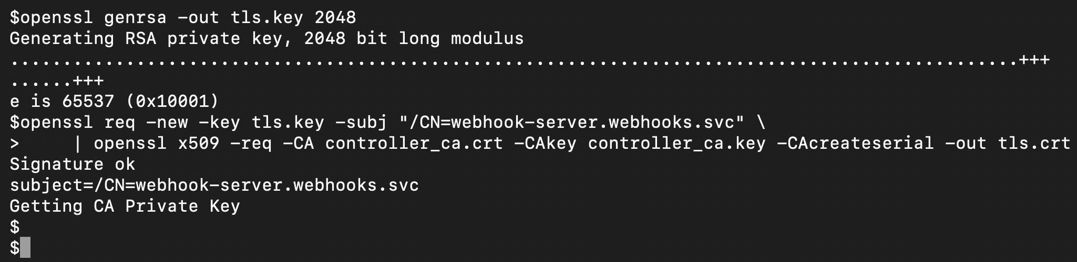

**Figure 16.20: Signing a private/public key pair with our certificate**

* + - 1. Create a secret that holds the private/public key pair:

kubectl -n webhooks create secret tls webhook-server-tls --cert "tls. crt" --key "tls.key"

You should see the following response:

secret/webhook-server-tls created

* + - 1. Now, create a file named **mutatingcontroller.go** with the code

for the webhook. A reference code for the webhook is provided at this link:

<https://packt.live/3bCS16D>.

* + - 1. To build an image, create a file named **Dockerfile** with the following content:

FROM golang:alpine as builder

LABEL version="1.0" \ [maintainer=»name@example.com»](mailto:name@example.com)

RUN mkdir /go/src/app && apk update && apk add --no-cache git && go get -u github.com/golang/dep/cmd/dep

COPY ./*.go ./Gopkg.toml /go/src/app/ WORKDIR /go/src/app

RUN dep ensure -v

RUN CGO_ENABLED=0 GOOS=linux go build -a -installsuffix cgo -o main .

FROM registry.fedoraproject.org/fedora-minimal:32 RUN groupadd appgroup && useradd appuser -G appgroup COPY --from=builder /go/src/app/main /app/

WORKDIR /app

USER appuser CMD ["./main"]

This example is using the Docker multi-stage build. In the first stage, the code is compiled. In the second stage, we are getting the compiled code and building a container that contains just the binary.

**NOTE**

This will work even if you do not use a multi-stage build and instead go with a simple build, as demonstrated in *Chapter 1*, *Understanding Kubernetes and Containers*. If you want to know more about multi-stage builds, refer to this link: <https://docs.docker.com/develop/develop-images/multistage-build/>.

* + - 1. Now, we can build the container using the following command:

docker build -t webhooks:0.0.1 .

You should see the following output:

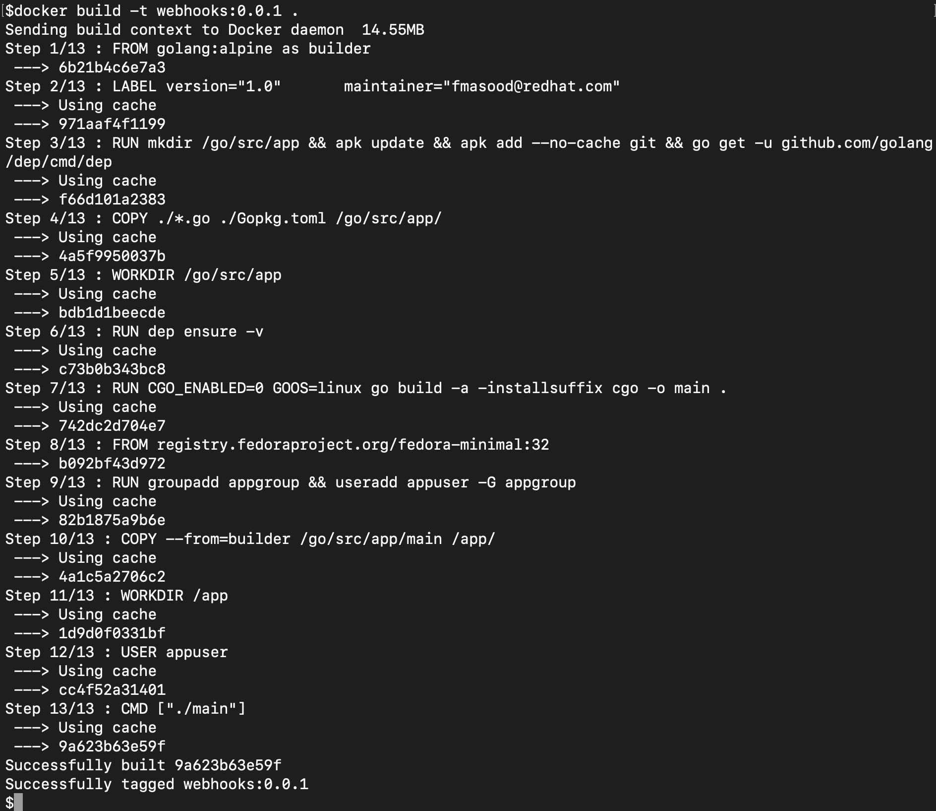

**Figure 16.21: Building the Docker image for our webhook**

* + - 1. Now push the packaged container to a public repository. We have used **quay. io**, which allows you to create a free public repository. The push is a two-step

process: the first step is to tag the local container, and the second step is to push

it up. Use the following two commands, one after the other:

docker tag webhooks:0.0.1 YOUR_REPO_NAME/webhooks:0.0.1

docker push YOUR_REPO_NAME/webhooks:0.0.1

Change these commands as per your repository. You should see the following response:

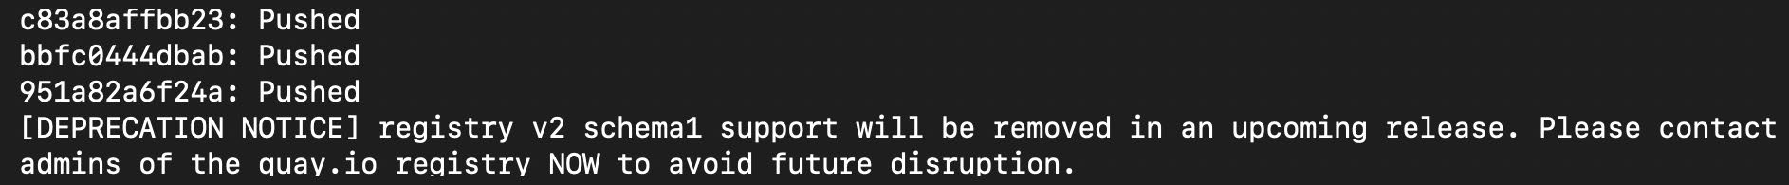

**Figure 16.22: Pushing the Docker image to a public repository**

* + - 1. Now we need to deploy the webhook in the **webhooks** namespace. For that, first, define a Deployment by creating a file, named **mutating-server.yaml**, with the following content:

apiVersion: apps/v1 kind: Deployment metadata:

name: webhook-server labels:

app: webhook-server spec:

replicas: 1 selector:

matchLabels:

app: webhook-server template:

metadata: labels:

app: webhook-server spec:

containers:

- name: server

**image: fenago/the-kubernetes-workshop:webhook**

imagePullPolicy: Always ports:

* containerPort: 8443 name: webhook-api

volumeMounts:

* **name: webhook-tls-certs** mountPath: /etc/secrets/tls readOnly: true

volumes:

- **name: webhook-tls-certs**

secret:

secretName: webhook-server-tls

**NOTE**

If you are using the image you have built and uploaded to your own repository as per the previous steps, remember to update the **image** field in this specification. Otherwise, you can keep it the same, and the Pod will fetch the reference image that we have provided.

There are two important sections in this definition. The first is the image location and the second is the Kubernetes secret, which contains the SSL certificates for the webhook server.

* + - 1. Deploy the webhook server with this definition using the following command:

kubectl create -f mutating-server.yaml -n webhooks

You should see the following response:

deployment.apps/webhook-server created

* + - 1. You might need to wait a bit and check whether the webhook Pods have been created. Keep checking the status of the Pods:

kubectl get pods -n webhooks -w

You should see the following response:

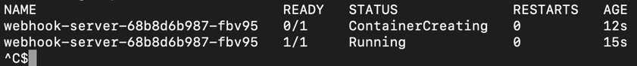

**Figure 16.23: Checking the status of our webhook server**

Note that the **-w** flag continuously watches the Pods. You can end the watch

using *Ctrl* + *C* when all the Pods are ready.

* + - 1. Expose the deployed webhook server via a Kubernetes service. Create a file

named **mutating-serversvc.yaml** using the following definition:

apiVersion: v1 kind: Service metadata:

labels:

app: webhook-server name: webhook-server namespace: webhooks

spec:

ports:

**- port: 443** protocol: TCP targetPort: 8443

selector:

app: webhook-server sessionAffinity: None type: ClusterIP

Note that the webhook service has to be running on port **443**, as this is the

standard port used for SSL connections.

* + - 1. Create the service with this definition using the following command:

kubectl create -f mutating-serversvc.yaml -n webhooks

You should see the following response:

service/webhook-server created

* + - 1. Create a Base64-encoded version of the CA certificate. The first command is to convert the certificate into a PEM format. And the second one is to convert the PEM certificate into Base64:

openssl x509 -inform PEM -in controller_ca.crt > controller_ca.crt.

pem

openssl base64 -in controller_ca.crt.pem -out controller_ca-base64. crt.pem

The terminal shows no response once these commands have been successfully executed. You can inspect the file using your favorite text editor, or the **cat** command, as follows:

cat controller_ca-base64.crt.pem

The file contents should be similar to the following figure. Please note that the TLS certificates you generate will not look exactly like what is shown here:

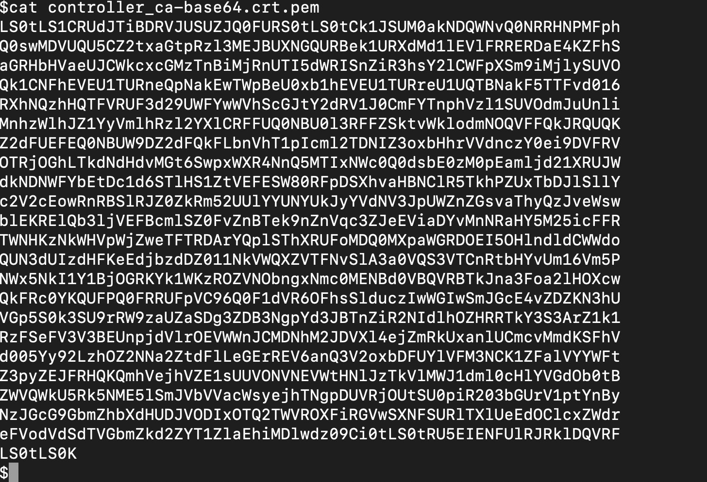

**Figure 16.24: Contents of the Base64-encoded CA certificate**

* + - 1. Now we need to remove the blank lines from our Base64-encoded certificate.

For that, you can use the following command:

cat controller_ca-base64.crt.pem | tr -d '\n' > onelinecert.pem

This command shows no response. You can see the new file by issuing the

following command:

cat onelinecert.pem

The contents of the file should look like this:

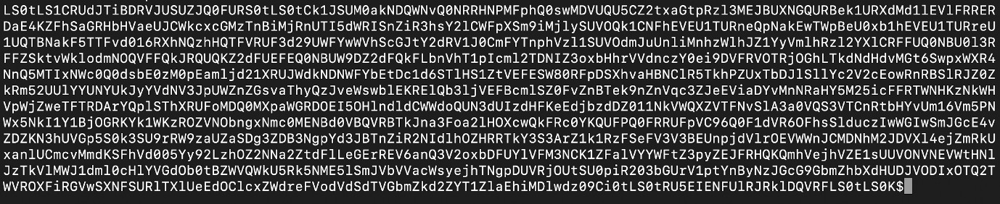

**Figure 16.25: Base64-encoded CA certificate with the line breaks removed**

Now we have the Base64-encoded certificate with no blank lines. For the next step, we will copy the value that you get in this output, being careful not to copy the **$** (which would be **%**, in the case of Zsh) at the end of the value. Paste this value in place of **CA_BASE64_PEM** (a placeholder for **caBundle**) in **mutating-config.yaml**, which will be created in the next step.

* + - 1. Create a **MutatingWebhookConfiguration** object using the following specification to configure the Kubernetes API server to call our webhook. Save this file as **mutating-config.yaml**:

apiVersion: admissionregistration.k8s.io/v1beta1

kind: MutatingWebhookConfiguration

metadata:

name: pod-annotation-webhook webhooks:

- name: webhook-server.webhooks.svc

clientConfig:

service:

name: webhook-server namespace: webhooks path: «/mutate»

**caBundle: "CA_BASE64_PEM" #Retain the quotes when you copy the caBundle here. Please read the note below on how to add specific values here.**

rules:

- operations: [ «CREATE" ] apiGroups: [""] apiVersions: ["v1"] resources: [«pods»]

**NOTE**

The **CA_BASE64_PEM** placeholder will be replaced with the contents of **onelinecert.pem** from the previous step. Be careful not to copy any line breaks. Remember that this is the value of the CA certificate with blank lines from the Base64-encoded value obtained in *step 15*.

* + - 1. Create the **MutatingWebHookConfiguration** object using the following command:

kubectl create -f mutating-config.yaml -n webhooks

You should see the following response:

mutatingwebhookconfiguration.admissionregistration.k8s.io/

pod-annotation-webhook created

* + - 1. Confirm that the webhook server Pod is running:

kubectl get pods -n webhooks | grep webhook-server

You should see this response:

webhook-server-6f7957bbf5-pbbcn 1/1 Running 1 18h

So, we have confirmation that our webhook is running. Now, let's test whether it

is working as expected in the following steps.

* + - 1. Create a simple Pod with no annotations. Use the following Pod specification and create a file named **target-pod.yaml**:

apiVersion: v1 kind: Pod metadata:

name: mutating-pod-example spec:

containers:

- name: cmutating-pod-example-container image: k8s.gcr.io/busybox

command: [ «/bin/sh", "-c", "while :; do echo '.'; sleep

5 ; done" ]

Note that there is no annotation defined in this specification.

* + - 1. Use the following command to create the Pod:

kubectl create -f target-pod.yaml -n webhooks

You will see the following response:

pod/mutating-pod-example created

* + - 1. Issue the following command to describe the Pod to check whether the annotation has been inserted:

kubectl describe pod mutating-pod-example -n webhooks

You should get the following output:

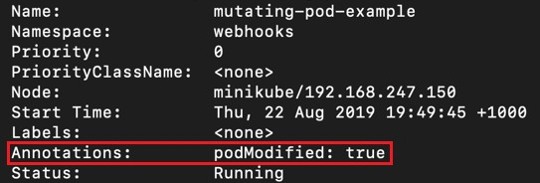

**Figure 16.26: Checking the mutations on our sample Pod**

This output has been truncated for brevity. As you can see, the webhook code is inserting the annotation with the name as **podModified** and the value as **true**, which is what we had coded.

We can now intercept the API traffic and change the object as per our requirements. This is useful for various purposes such as audits, policy enforcement, quotas, standards, and much more.

## ACTIVITY 16.02: CREATING A VALIDATING WEBHOOK THAT CHECKS FOR A LABEL IN A POD

### Solution:

* + - * 1. To prevent various objects from interfering with each other, please make sure that you delete the existing **webhooks** namespace:

kubectl delete ns webhooks

You should see the following response:

namespace "webhooks" deleted

* + - * 1. Now recreate the **webhooks** namespace:

kubectl create ns webhooks

You should see the following response:

namespace/webhooks created

* + - * 1. Generate a self-signed certificate using this command:

openssl req -nodes -new -x509 -keyout controller_ca.key -out controller_ca.crt -subj "/CN=Mutating Admission Controller Webhook CA"

You will see the following response:



**Figure 16.27: Generating a self-signed certificate**

* + - * 1. Generate a private/public key pair and sign it with the CA certificate using the

following two commands, one after the other:

openssl genrsa -out tls.key 2048

openssl req -new -key tls.key -subj "/CN=webhook-server.webhooks.svc"

\

| openssl x509 -req -CA controller_ca.crt -CAkey controller_

ca.key -CAcreateserial -out tls.crt

You should see the following response:

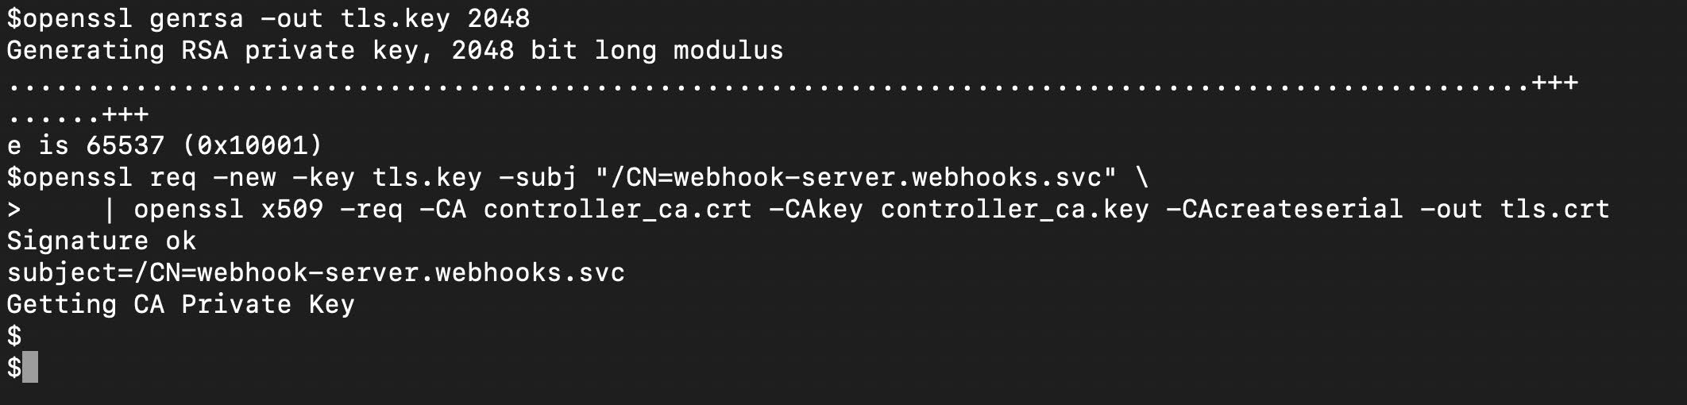

**Figure 16.28: Signing the private/public key pair with our certificate**

* + - * 1. Create a secret that holds the private/public key pair:

kubectl -n webhooks create secret tls webhook-server-tls \

--cert "tls.crt" \

--key "tls.key"

You should see the following response:

secret/webhook-server-tls created

* + - * 1. Create a file, named **validatecontroller.go**, with the code for the webhook server. The reference code is provided at this link: <https://packt.live/3bAlHB4>.
        2. Now, create the **Dockerfile** for containerizing this application. The reference **Dockerfile** shown here uses a multi-stage build, but you can also use a simple build:

FROM golang:alpine as builder

LABEL version="1.0" \ [maintainer=»name@example.com»](mailto:name@example.com)

RUN mkdir /go/src/app && apk update && apk add --no-cache git && go get -u github.com/golang/dep/cmd/dep

COPY ./*.go ./Gopkg.toml /go/src/app/ WORKDIR /go/src/app

RUN dep ensure -v

RUN CGO_ENABLED=0 GOOS=linux go build -a -installsuffix cgo -o main .

FROM registry.fedoraproject.org/fedora-minimal:32 RUN groupadd appgroup && useradd appuser -G appgroup COPY --from=builder /go/src/app/main /app/

WORKDIR /app USER appuser CMD ["./main"]

* + - * 1. Using the **Dockerfile** shown in the previous step, which is available in the code repository, build the container using the **docker build** command, as follows:

docker build -t webhooks:0.0.1 .

You should see the following output:



**Figure 16.29: Building the Docker image**

* + - * 1. Now, push the packaged container to a public repository. The push is a two-step

process – the first step is to tag the local container and the second step is to push your local container to a central repository. Use the following two commands in the given order:

docker tag webhooks:0.0.1 YOUR_REPO_NAME/webhooks:0.0.1

docker push YOUR_REPO_NAME/webhooks:0.0.1

You should see the following response:



**Figure 16.30: Pushing the Docker image to a public repository**

* + - * 1. Next, we need to define a Deployment to deploy the webhook in the **webhooks** namespace. Create a file named **validating-server.yaml** with the following content:

apiVersion: apps/v1 kind: Deployment metadata:

name: webhook-server labels:

app: webhook-server spec:

replicas: 1 selector:

matchLabels:

app: webhook-server template:

metadata: labels:

app: webhook-server spec:

containers:

- name: server

**image: fenago/the-kubernetes-workshop:webhook**

imagePullPolicy: Always ports:

- containerPort: 8443

name: webhook-api

**volumeMounts:**

**- name: webhook-tls-certs mountPath: /etc/secrets/tls readOnly: true**

volumes:

- name: webhook-tls-certs secret:

secretName: webhook-server-tls

Note that there is one important section in this definition that is different from the previous activity – the Kubernetes secret, which contains the SSL certificates, for the webhook server.

* + - * 1. Deploy the webhook server by using the Deployment defined in the

previous step:

kubectl create -f validating-server.yaml -n webhooks

You should see the following response:

deployment.apps/webhook-server created

* + - * 1. You might need to wait a bit and check whether the webhook Pods have been created. Keep checking the status of the Pods:

kubectl get pods -n webhooks -w

You should see the following response:



**Figure 16.31: Checking whether the webhook Pod is online**

Note that the **-w** flag continuously watches the Pods. You can end the watch

when all the Pods are ready.

* + - * 1. Now, we have to expose the deployed webhook server via the Kubernetes service. Create a file named **validating-serversvc.yaml** with the following content:

apiVersion: v1 kind: Service metadata:

labels:

app: webhook-server name: webhook-server namespace: webhooks

spec:

ports:

**- port: 443** protocol: TCP targetPort: 8443

selector:

app: webhook-server sessionAffinity: None type: ClusterIP

Note that the webhook service has to be running on port **443**.

* + - * 1. Use the definition from the previous step to create the service using the

following command:

kubectl create -n webhooks -f validating-serversvc.yaml

You should see the following output:

service/webhook-server created

* + - * 1. Create a Base64-encoded version of the CA certificate. Use the following

commands, one after the other:

openssl x509 -inform PEM -in controller_ca.crt > controller_ca.crt.

pem

openssl base64 -in controller_ca.crt.pem -out controller_ca-base64. crt.pem

The first command is to convert the certificate into a PEM format. And the second one is to convert the PEM certificate into Base64. These commands show no response. You can inspect the file using the following command:

cat controller_ca-base64.crt.pem

The file contents should be similar to the following figure:



**Figure 16.32: The contents of the Base64-encoded CA certificate**

Please note that the TLS certificates you will generate will not look exactly like

what is shown here.

* + - * 1. Use the following two commands to clean up the blank lines from our CA

certificate and add the contents to a new file:

cat controller_ca-base64.crt.pem | tr -d '\n' > onelinecert.pem

cat onelinecert.pem

The first command shows no response, and the second one prints out the

contents of **onelinecert.pem**. You should see the following response:

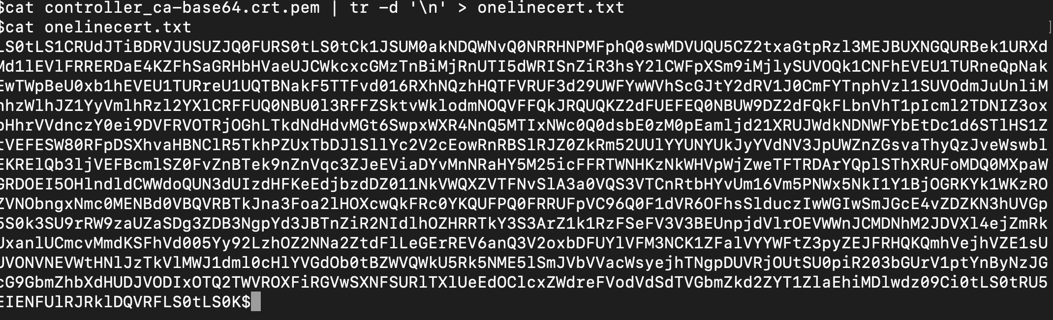

**Figure 16.33: Base64-encoded CA certificate with the line breaks removed**

Now, we have the Base64-encoded certificate with no blank lines. For the next step, we will copy the value that you get in this output, being careful not to copy the **$** (which would be **%**, in the case of Zsh) at the end of the value.

Paste this value in place of **CA_BASE64_PEM** (a placeholder for **caBundle**) in

**validating-config.yaml**, which will be created in the next step.

* + - * 1. Create a file, named **validation-config.yaml**, using the following **ValidatingWebHookConfiguration** specification to configure the Kubernetes API server and call our webhook:

apiVersion: admissionregistration.k8s.io/v1beta1

kind: ValidatingWebhookConfiguration

metadata:

name: pod-label-verify-webhook webhooks:

- name: webhook-server.webhooks.svc

clientConfig:

service:

name: webhook-server namespace: webhooks path: «/validate»

caBundle: **"CA_BASE64_PEM" #Retain the quotes when you copy the caBundle here. Please read the note below on how to add specific values here.**

rules:

- operations: [ «CREATE" ] apiGroups: [""] apiVersions: ["v1"] resources: [«pods»]

**NOTE**

The **CA_BASE64_PEM** placeholder will be replaced with the contents of **onelinecert.pem** from the previous step. Be careful not to copy any line breaks. Remember that this is the value of the CA certificate with blank lines from the Base64-encoded value obtained in *step 14*.

* + - * 1. Create the **ValidatingWebHookConfiguration** object using the following command:

kubectl create -f validation-config.yaml -n webhooks

You should see the following response:

**Figure 16.34: Creating the ValidatingWebhookConfiguration object**

* + - * 1. Create a simple Pod with no labels. Use the following Pod specification to create a file named **target-validating-pod.yaml**:

apiVersion: v1 kind: Pod metadata:

name: validating-pod-example spec:

containers:

- name: validating-pod-example-container image: k8s.gcr.io/busybox

command: [ «/bin/sh", "-c", "while :; do echo '.'; sleep

5 ; done" ]

* + - * 1. Create the Pod defined in the previous step:

kubectl create -f target-validating-pod.yaml -n webhooks

You should see the following response:



**Figure 16.35: Pod getting rejected by the validating webhook**

Note that the Pod creation is rejected as there is a **labels** section defined in the Pod specification in the previous step.

* + - * 1. Now, modify the definition in *step 19* to add the **teamName** label. This is the key of the label that our validating webhook will try to validate. Your specification should look like this:

apiVersion: v1 kind: Pod metadata:

name: validating-pod-example

**labels:**

**teamName: kubeteam**

spec:

containers:

- name: validating-pod-example-container image: k8s.gcr.io/busybox

command: [ «/bin/sh", "-c", "while :; do echo '.'; sleep

5 ; done" ]

* + - * 1. Try creating the Pod again:

kubectl create -f target-validating-pod.yaml -n webhooks

You will see the following response:

pod/validating-pod-example created

Note that the Pod is created this time.

* + - * 1. Issue the following command to describe the Pod to check the label:

kubectl describe pod validating-pod-example -n webhooks

You should see the following output:

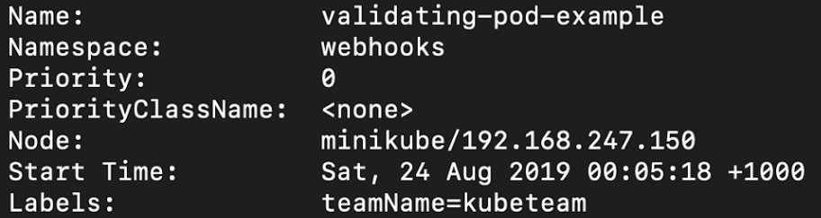

**Figure 16.36: Checking the annotations of our Pod**

Note that we have truncated the output for brevity. As you can see, the Pod was created because we had added the required label to it.

Therefore, we have learned how to intercept the API traffic and allow/reject the

object (or Pod, in this case) creation as per our requirements.

# CHAPTER 17: ADVANCED SCHEDULING IN KUBERNETES

## ACTIVITY 17.01: CONFIGURING A KUBERNETES SCHEDULER TO SCHEDULE PODS

### Solution:

1. Create a new namespace:

kubectl create ns scheduleractivity

This should give the following response:

namespace/scheduleractivity created

1. Create a file named **pod-priority-api.yaml** with the following contents:

apiVersion: scheduling.k8s.io/v1 kind: PriorityClass

metadata:

name: api-pod-priority value: 9999 globalDefault: false

description: "This priority class should be used for API pods."

1. Create a Pod priority using the priority class that we defined in the

previous step:

kubectl create -f pod-priority-api.yaml -n scheduleractivity

This will give the following response:

priorityclass.scheduling.k8s.io/api-pod-priority created

1. Create a file named **api-pod-deploy.yaml** using the following content:

apiVersion: apps/v1 kind: Deployment metadata:

name: api-pod labels:

app: api-pod spec:

replicas: 1 selector:

matchLabels: app: api-pod

template: metadata:

labels:

app: api-pod spec:

priorityClassName: api-pod-priority containers:

- name: api-pod

image: k8s.gcr.io/busybox imagePullPolicy: Always

command: [ «/bin/sh", "-c", "while :; do echo 'this is API pod'; sleep 3 ; done" ]

resources: limits:

cpu: "0.1" memory: «100Mi»

requests: cpu: "0.1"

memory: «100Mi»

1. Create the Deployment defined in the previous step to get the API Pod running:

kubectl create -f api-pod-deploy.yaml -n scheduleractivity

You will see the following response:

deployment.apps/api-pod created

1. Verify that the API Pods are running:

kubectl get pods -n scheduleractivity

You should get the following response



**Figure 17.23: Getting the list of Pods**

1. Create a file named **gui-pod-deploy.yaml** with the following content:

apiVersion: apps/v1 kind: Deployment metadata:

name: gui-pod labels:

app: gui-pod spec:

replicas: 1 selector:

matchLabels: app: gui-pod

template: metadata:

labels:

app: gui-pod spec:

affinity: podAffinity:

requiredDuringSchedulingIgnoredDuringExecution:

- labelSelector: matchExpressions:

- key: app operator: In

values:

- api-pod

topologyKey: kubernetes.io/hostname

containers:

- name: gui-pod

image: k8s.gcr.io/busybox imagePullPolicy: Always

command: [ «/bin/sh", "-c", "while :; do echo 'this is GUI pod'; sleep 5 ; done" ]

resources: limits:

cpu: "0.1" memory: «100Mi»

requests: cpu: "0.1"

memory: «100Mi»

1. Create the GUI Pod using the Deployment that we defined in the previous step:

kubectl create -f gui-pod-deploy.yaml -n scheduleractivity

You will see the following response:

deployment.apps/gui-pod created

1. Verify that both the API and GUI Pods are running:

kubectl get pods -n scheduleractivity

You will see the following list of Pods:

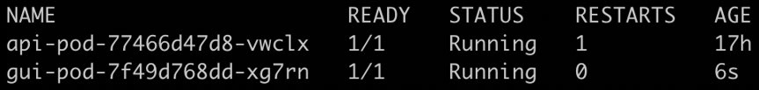

**Figure 17.24: Getting the list of Pods**

1. Scale up the number of replicas for the API Pod to **2**:

kubectl scale deployment/api-pod --replicas=2 -n scheduleractivity

You should see the following response:

deployment.extensions/api-pod scaled

1. Scale up the number of replicas for the GUI Pod to **2**:

kubectl scale deployment/gui-pod --replicas=2 -n scheduleractivity

You will see the following response:

deployment.extensions/gui-pod scaled

1. Verify that two Pods each for API and GUI are running:

kubectl get pods -n scheduleractivity

You should see the following list of Pods:

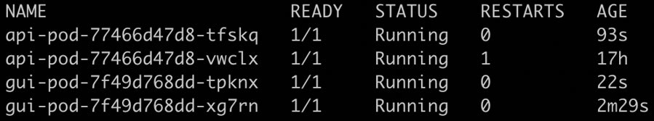

**Figure 17.25: Getting the list of pods**

1. Create a file named **pod-priority-realtime.yaml** with the following content:

apiVersion: scheduling.k8s.io/v1 kind: PriorityClass

metadata:

name: realtime-pod-priority value: 100000

globalDefault: false

description: "This priority class should be used for pods with the highest of priority."

1. Create the Pod priority using the priority class definition from the previous step:

kubectl create -f pod-priority-realtime.yaml -n scheduleractivity

You should see the following response:

priorityclass.scheduling.k8s.io.realtime-pod-priority created

1. Create a file named **realtime-pod-deploy.yaml** with the following content:

apiVersion: apps/v1 kind: Deployment metadata:

name: realtime-pod labels:

app: realtime-pod spec:

replicas: 1 selector:

matchLabels:

app: realtime-pod template:

metadata: labels:

app: realtime-pod spec:

priorityClassName: realtime-pod-priority containers:

- name: realtime-pod

image: k8s.gcr.io/busybox imagePullPolicy: Always

command: [ «/bin/sh", "-c", "while :; do echo 'this is REALTIME pod'; sleep 1 ; done" ]

resources: limits:

cpu: "0.1" memory: «100Mi»

requests: cpu: "0.1"

memory: «100Mi»

1. Create this Deployment to get the real-time Pods running:

kubectl create -f realtime-pod-deploy.yaml -n scheduleractivity

You will see the following response:

deployment.apps/realtime-pod created

1. Verify that the Pods are running:

kubectl get pods -n scheduleractivity

You should see the following list of Pods:

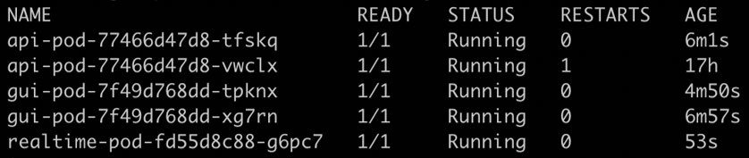

**Figure 17.26: Getting the list of Pods**

1. For the real-time Pod, scale up the number of replicas to **10**:

kubectl scale deployment/realtime-pod --replicas=10 -n scheduleractivity

You should see the following response:

deployment.extensions/realtime-pod scaled

1. Now, let's check the current status of Pods:

kubectl get pods -n scheduleractivity

You should see a response that's something like this:

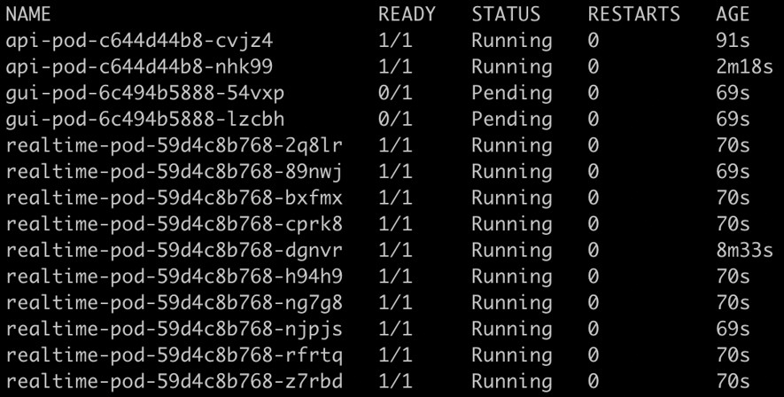

**Figure 17.27: Getting the list of Pods**

As you can see in the preceding image, all API Pods are running. You may observe that for your case, some of the API or GUI Pods have moved to the **Pending** state. If you do not observe this on your machine, try increasing the number of real-time Pod replicas by a factor of 5.

1. Use the following command to increase the number of real-time Pod replicas to **12**:

kubectl scale deployment/realtime-pod --replicas=12 -n scheduleractivity

Note that we are trying to demonstrate that as the cluster is limited by resources, some of the lower-priority Pods get evicted. Here, we are scaling the real-time Pods to **12**. You may need to experiment a bit to see how many Pods you need to hit the resource limits of your environment. You should see the following response:

deployment.extensions/realtime-pod scaled

1. Check whether the real-time Pods are running and the API and GUI Pods are in the **Pending** state:

kubectl get pods -n scheduleractivity

You should see the following list of Pods:

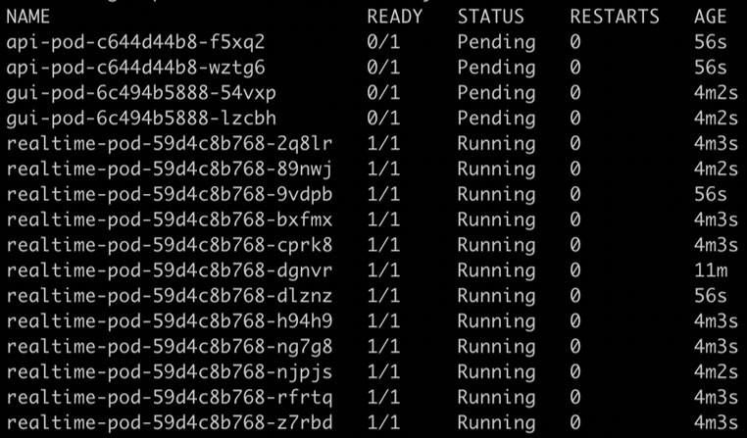

**Figure 17.28: Getting the list of Pods**

1. Bring the number of replicas of the real-time Pod back to **1**:

kubectl scale deployment/realtime-pod --replicas=1 -n scheduleractivity

You should see the following response:

deployment.extensions/realtime-pod scaled

This should free up resources to schedule our GUI and API Pods.

1. Check whether the Pods are running:

kubectl get pods -n scheduleractivity

You should see the following list of Pods.

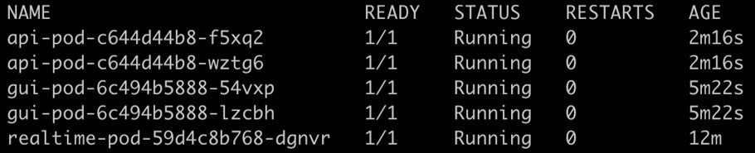

**Figure 17.29: Getting the list of Pods**

# CHAPTER 18: UPGRADING YOUR CLUSTER WITHOUT DOWNTIME

## ACTIVITY 18.01: UPGRADING THE KUBERNETES PLATFORM FROM VERSION 1.15.7 TO 1.15.10

### Solution:

In this activity, we will perform a full upgrade to the cluster, similar to the upgrade we performed through all the exercises in the chapter:

1. Check the version of kops and ensure that it is **1.15**:

kops version

You should get this response:

Version 1.15.0 (git-9992b4055)

1. Use the **kops upgrade cluster** command to see what update is available:

kops upgrade cluster ${NAME}

You should see a response similar to the following:

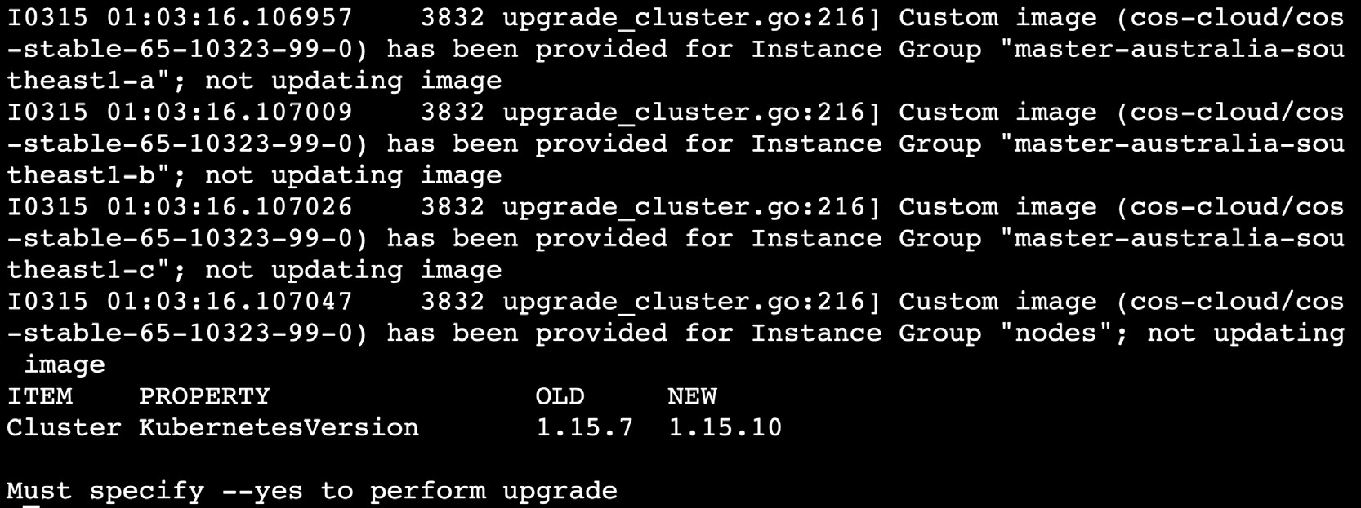

**Figure 18.35: Checking the available upgrade for our cluster**

You can see from the preceding screenshot that the **OLD** version is **1.15.7**, which is our current version, and an update is available to the **NEW** version (**1.15.10**), which is our target version.

1. Once you verify the changes from the command in the previous step, run the same command with the **--yes** flag:

kops upgrade cluster --yes

You should see a response similar to the following:

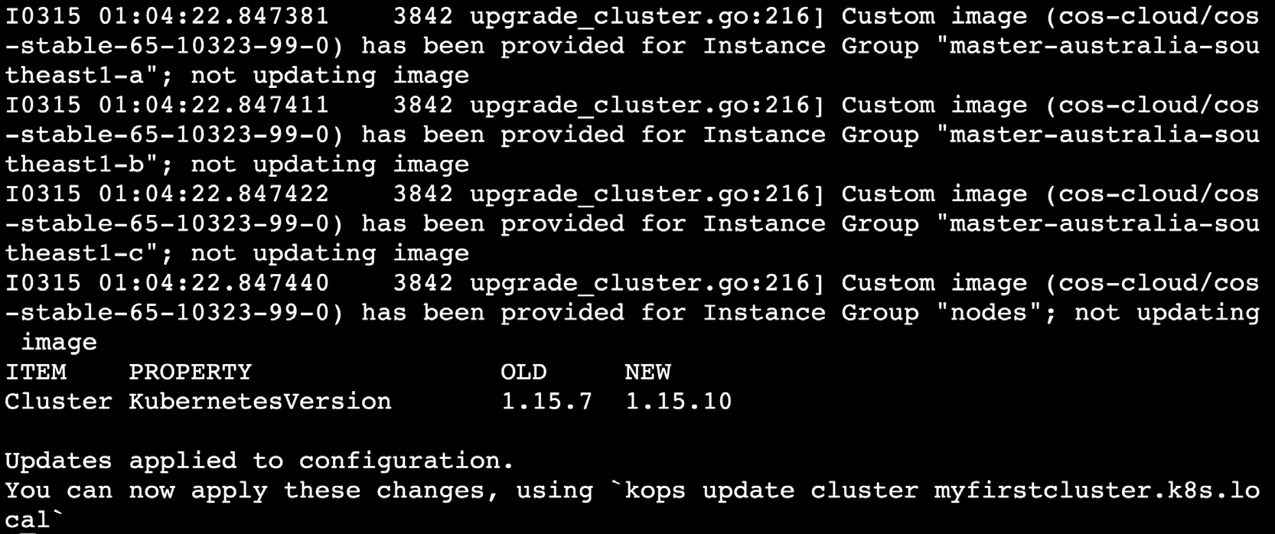

**Figure 18.36: Updating the kops configuration of our cluster**

1. This command will update the cloud and cluster resources as per the kops desired state set in the previous step:

kops update cluster ${NAME} --yes

You should see a response similar to this:

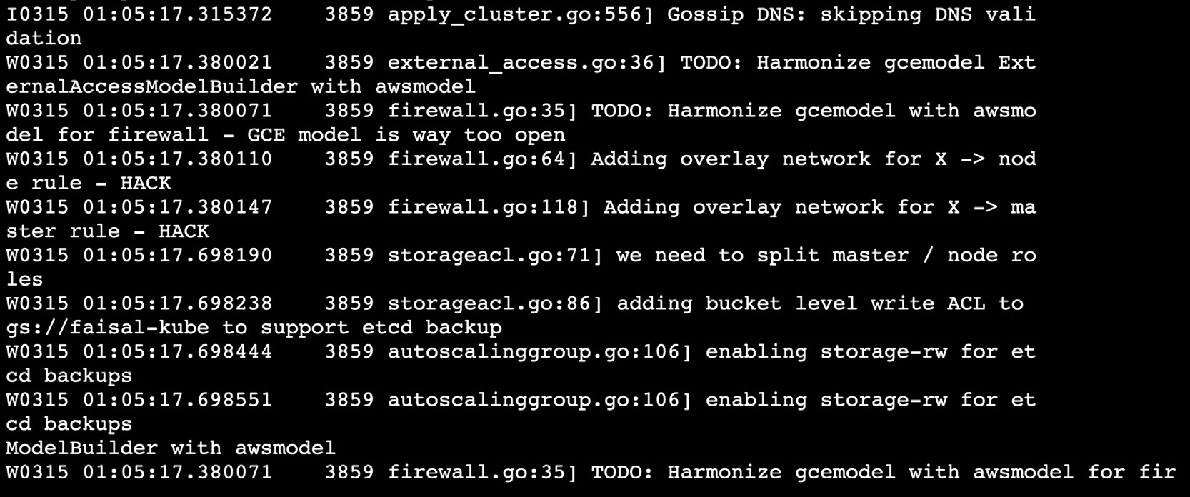

**Figure 18.37: Updating our infrastructure to meet the requirements of our upgrade**

1. Get a list of the instance groups for your worker nodes. Note that the name of the instance group for our worker nodes is **nodes**:

kops get instancegroups

You should get an output similar to the following:

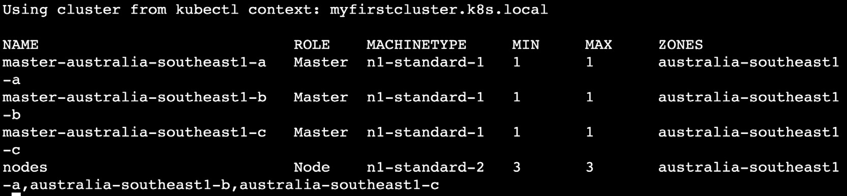

**Figure 18.38: Getting a list of the instance groups**

1. Upgrade the first master node to the new version:

kops rolling-update cluster ${NAME} --instance-group master- australia-southeast1-a --yes

Use the appropriate name of the instance group for your case. This command may take time based on your node configuration. Be patient and watch the logs to see whether there are any errors. After some time, you will see a successful message:

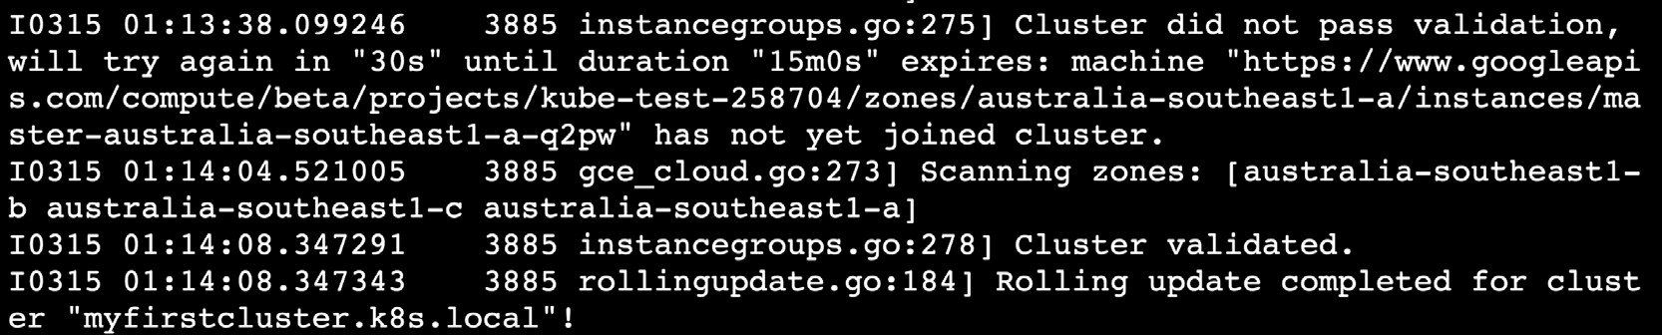

**Figure 18.39: Applying a rolling update to the instance group running the first master node**

1. Verify that the node is upgraded to the target version, which is **1.15.10**, in our case:

kubectl get nodes

You should see a response similar to the following:

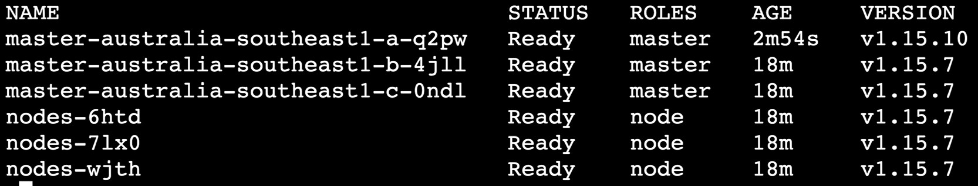

**Figure 18.40: Checking the version of Kubernetes on the first master node**

You can see that the first master node is on version **1.15.10**.

1. Apply the previous two steps to all the master nodes:
2. Verify that the nodes are ready:

kubectl get nodes

You should see a response similar to the following:

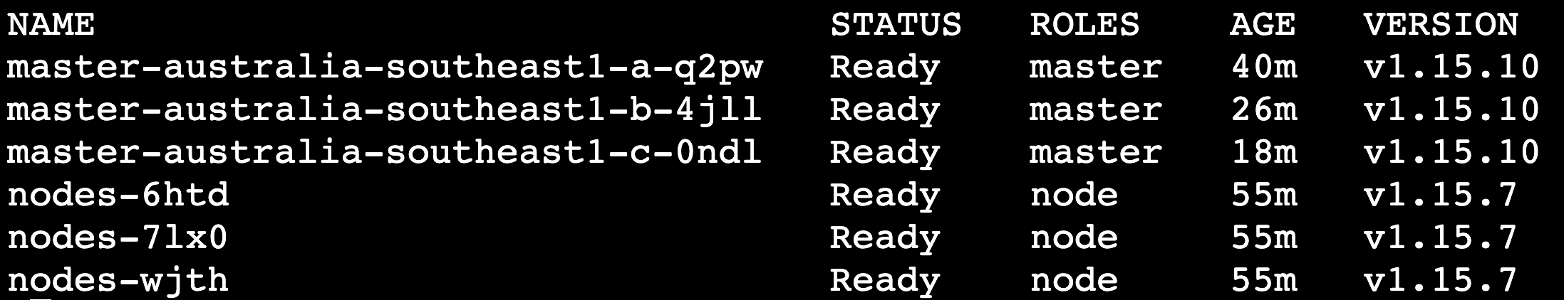

**Figure 18.41: Checking the version of Kubernetes on all the master nodes**

1. Now, we need to upgrade the worker nodes. To keep things simple, we only have one instance group for the worker nodes, named **nodes**. Run **kops rolling- update** for the **nodes** instance group without the **--yes** flag:

kops rolling-update cluster ${NAME} --node-interval 3m --instance- group nodes --post-drain-delay 3m --logtostderr --v 1

You should see the following response:

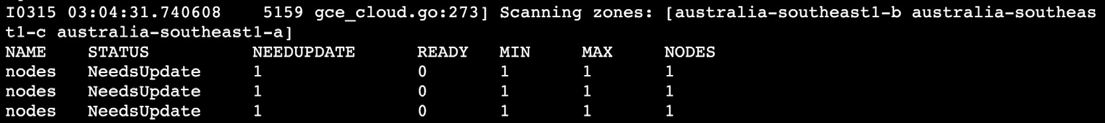

**Figure 18.42: Performing a dry run of the rolling update on the worker nodes**

This will provide you with a summary of what will be updated with this command.

1. Now, run the upgrade by using the same command from the previous step but with a **--yes** flag. This tells kops to actually perform the upgrade:

kops rolling-update cluster ${NAME} --node-interval 3m --instance- group nodes --post-drain-delay 3m --yes

After a while, you will see that the cluster upgrade is finished with a success

message, as shown:



**Figure 18.43: Applying the rolling update to our worker nodes**

1. Verify that the worker node is updated to the target version, which is **1.15.10**

for this activity:

kubectl get nodes

You should see a response as follows:

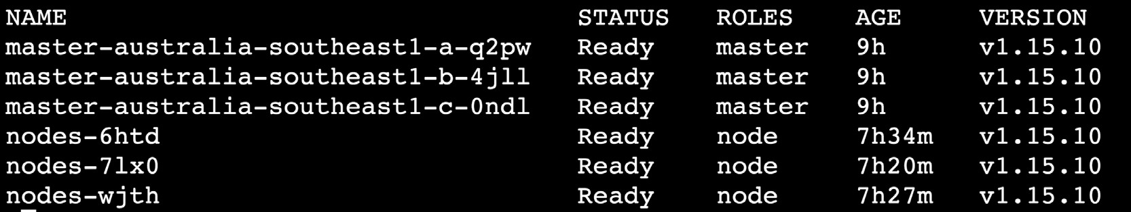

**Figure 18.44: Checking the version of Kubernetes on all the nodes**

As we can see in the preceding image, all of our master and worker nodes are running Kubernetes version **1.15.10**.

1. Verify that the pods are in a running state:

kubectl get pods -n upgrade-demo

You should see a response as follows:

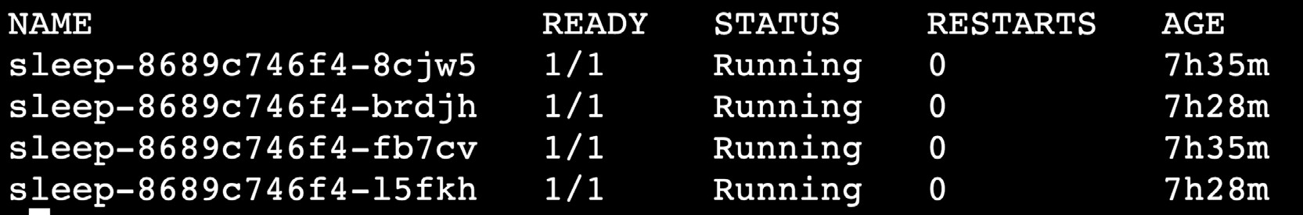

**Figure 18.45: Checking whether all the worker pods are running successfully**

Thus, all of our pods are running successfully.

# CHAPTER 19: CUSTOM RESOURCE DEFINITIONS IN KUBERNETES

## ACTIVITY 19.01: CRD AND CUSTOM CONTROLLER IN ACTION

### Solution:

* 1. We will start with a clean slate. First, delete the existing namespace:

kubectl delete ns crddemo

You should see the following response:

namespace "crddemo" deleted

* 1. Create a new namespace called **crddemo**:

kubectl create ns crddemo

You should see the following response:

namespace/crddemo created

* 1. Delete the CRD if it exists from the previous exercise and you have not created a new namespace:

kubectl get crd

kubectl delete crd podlifecycleconfigs.controllers.kube.book.au

You should see the following response:

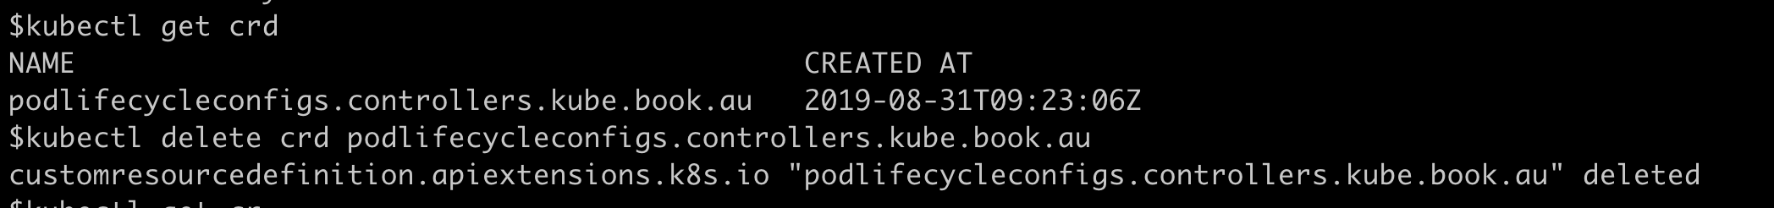

**Figure 19.11: Deleting the existing CRD**

* 1. Create a file named **pod-normaliser-crd.yaml** with the following specs:

apiVersion: apiextensions.k8s.io/v1beta1

kind: CustomResourceDefinition

metadata:

name: podlifecycleconfigs.controllers.kube.book.au

spec:

group: controllers.kube.book.au version: v1

scope: Namespaced names:

kind: PodLifecycleConfig plural: podlifecycleconfigs singular: podlifecycleconfig

#1.15 preserveUnknownFields: false validation:

openAPIV3Schema: type: object properties:

spec:

type: object properties:

namespaceName: type: string

podLiveForThisMinutes: type: integer

* 1. Create a CRD using the file created in the previous step:

kubectl create -f pod-normaliser-crd.yaml

You should see the following response:



**Figure 19.12: Creating our CRD**

* 1. Verify that it has been created:

kubectl get crd

You should see the following response:

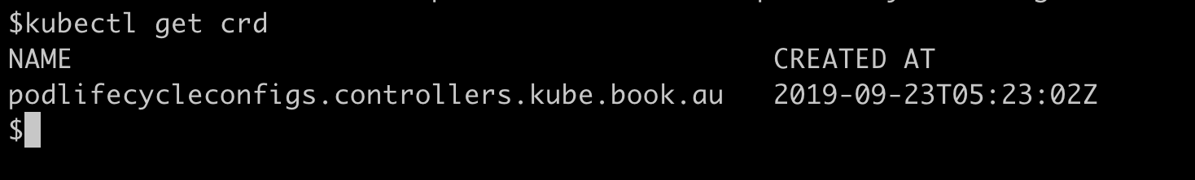

**Figure 19.13: Verifying that our CRD was created**

* 1. Now, we will create our CR. Create a file named **pod-normaliser.yaml**:

apiVersion: "controllers.kube.book.au/v1"

kind: PodLifecycleConfig

metadata:

name: demo-pod-lifecycle

# namespace: "crddemo" spec:

namespaceName: crddemo podLiveForThisMinutes: 1

* 1. Create the CR defined in the previous step:

kubectl create -f pod-normaliser.yaml -n crddemo

You will see the following response:

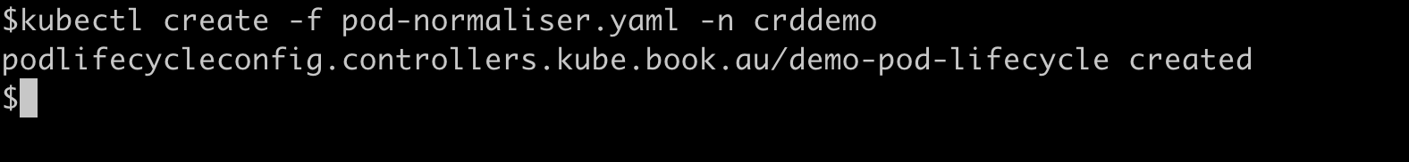

**Figure 19.14: Creating our CR**

This CR will live in the **crddemo** namespace and will allow Pods to live for only a minute.

* 1. Create a custom Role that will have access to get all the CRs we have defined. Use the file named **pod-normaliser-crd-roles.yaml** using the following content:

kind: Role

apiVersion: rbac.authorization.k8s.io/v1 metadata:

**name: podlifecycleconfig-crd-view**

namespace: crddemo labels:

rbac.authorization.k8s.io/aggregate-to-admin: "true" rbac.authorization.k8s.io/aggregate-to-edit: "true" rbac.authorization.k8s.io/aggregate-to-view: "true"

**rules**:

* apiGroups: ["controllers.kube.book.au"] resources: ["podlifecycleconfigs"] verbs: ["get", "list", "watch"]
* apiGroups: [""] # "" indicates the core API group resources: ["pods"]

verbs: ["get", "watch", "list", "delete"]

Note the **rules** section, where we are defining what would be accessible to

someone who has been granted this **Role**.

* 1. Use the definition from the previous step to create a Pod using the

following command:

kubectl create -f pod-normaliser-crd-roles.yaml -n crddemo

It should give the following response:



**Figure 19.15: Creating a custom Role to access our CRs**

* 1. Once the role has been created, let's associate this role with a service account. We need to associate the newly created role with the **default** ServiceAccount from the **crddemo** namespace by creating a RoleBinding. Create a file named **pod-normaliser-role-binding.yaml** using the following content:

kind: RoleBinding

apiVersion: rbac.authorization.k8s.io/v1beta1 metadata:

name: podlifecycleconfig-crd-view-binding

namespace: crddemo subjects:

**- kind: ServiceAccount name: default namespace: crddemo**

roleRef:

**kind: Role**

**name: podlifecycleconfig-crd-view**

apiGroup: ""

# rbac.authorization.k8s.io

Note that under the **subjects** section, we are referencing the **default** ServiceAccount, and in the **roleRef** section, we are referencing the newly created role in the previous step.

* 1. Create a RoleBinding object using the definition from the previous step:

kubectl create -f pod-normaliser-role-binding.yaml -n crddemo

You should see the following response:



**Figure 19.16: Creating our RoleBinding**

**NOTE**

You may choose to skip the part where we build the Docker image. We have provided a working Docker image for the controller. You can use the image tagged as **crd** at this link: https://hub.docker.com/r/fenago/the-kubernetes-workshop/tags

* 1. Now, we need to build and deploy the custom controller. We have provided a **Dockerfile**, along with the required code in the repository that will build the container for you:

cd controller && docker build -t crd:0.0.1 .

Don't miss the **.** (dot) character at the end of this command. This will give a long output, and upon successful completion, should end in a similar way to the following screenshot:

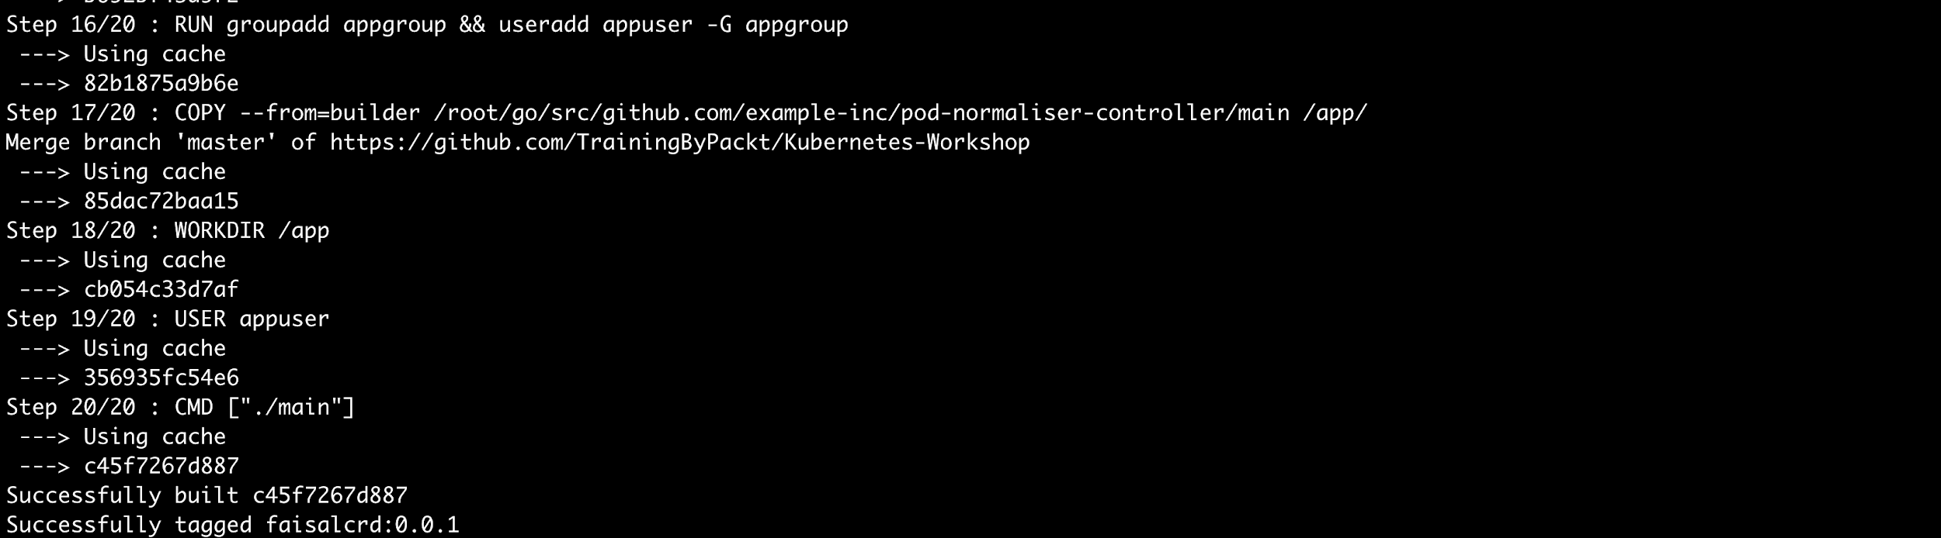

**Figure 19.17: Building our Docker container**

* 1. Tag and push the image to a public container registry of your choice. Make sure you replace the registry name as per your settings. Going with our choice of Docker repository, enter the following two commands, one after the other:

docker tag crd:0.0.1 <YOUR DOCKER REGISTRY>/crd:0.0.1

docker push <YOUR DOCKER REGISTRY>/crd:0.0.1

You should see the following response:

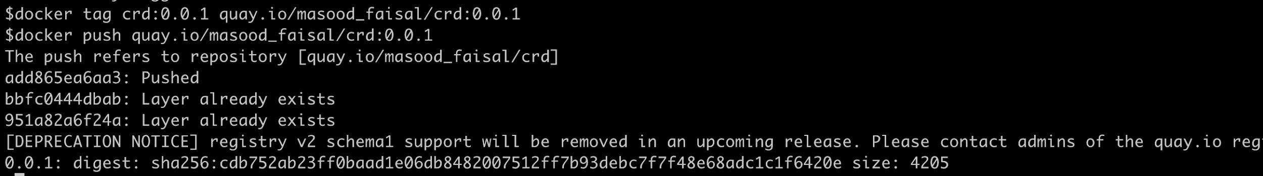

**Figure 19.18: Pushing our Docker image**

* 1. Now, let's define a Pod to run our custom controller. Create a file named

**crd-deploy.yaml** using the following content:

apiVersion: apps/v1 kind: Deployment metadata:

name: crd-server labels:

app: crd-server spec:

replicas: 1 selector:

matchLabels:

app: crd-server template:

metadata: labels:

app: crd-server spec:

containers:

* name: server

**image: fenago/the-kubernetes-workshop:crd**

env:

* + name: namespaceToWatch valueFrom:

fieldRef:

fieldPath: metadata.namespace

* + name: podName valueFrom:

fieldRef:

fieldPath: metadata.name

imagePullPolicy: Always

**NOTE**

If you are using a Docker image that you have created and pushed to your repository, then please replace the **image** field in the preceding Pod spec.

* 1. Deploy the custom controller to Kubernetes using the following command:

kubectl create -f crd-deploy.yaml -n crddemo

You should see the following response:

deployment.apps/crd-server created

* 1. Make sure that the custom controller Pod is up and running:

kubectl get pods -n crddemo -w

You should see the following list of Pods:

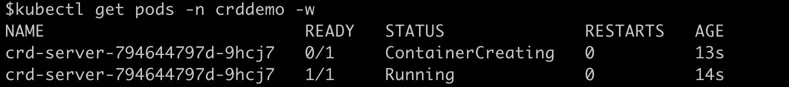

**Figure 19.19: Verifying that our custom controller is online**

Press *Ctrl* + *C* to terminate the watch when the Pod is running.

* 1. Check the controller pod logs. Remember to use the Pod name from the output of the previous step:

kubectl logs -f crd-server-794644797d-9hcj7 -n crddemo

You should see the following log:



**Figure 19.20: Checking the logs on our custom controller Pod**

Notice that the log says **A Custom Resource has been Added**. If you refer to the **AddFunc** code mentioned in the **types.go** file, you will find that that the log statement was in the **AddFunc** section of the code. What this means is that the CR defined in *step 7* has been found by the controller.

Remember that we are allowing Pods to run only for a minute. Let's test this by creating a simple Pod to see whether it gets killed.

* 1. Create the following pod specification, which is just a loop to keep the Pod working. Create a file named **target-pod.yaml** with the following definition:

apiVersion: v1 kind: Pod metadata:

name: long-running-pod-example spec:

containers:

- name: mutating-pod-example-container image: k8s.gcr.io/busybox

command: [ "/bin/sh", "-c", "while :; do echo '.'; sleep

5 ; done" ]

* 1. Next, create a Pod using the definition from the previous step:

kubectl create -f target-pod.yaml -n crddemo

You should see the following response:

pod/long-running-pod-example created

* 1. Now, let's watch the Pod for some time to see whether it is killed after a minute:

kubectl get pods -w -n crddemo

You should see an output similar to the following:

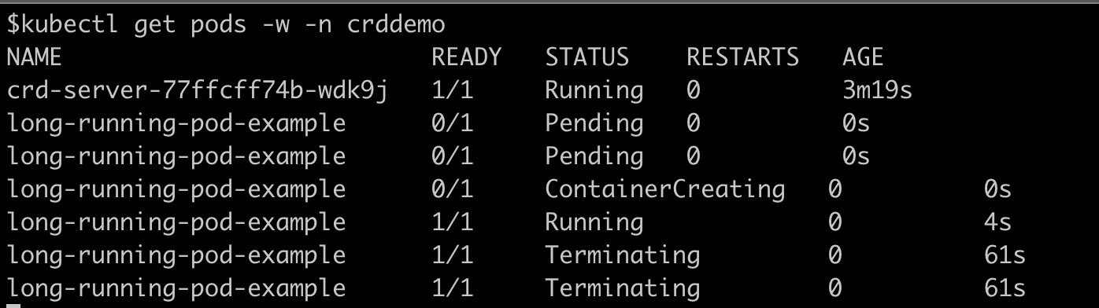

**Figure 19.21: Observing our sample Pod**

Remember that our CR set the value for the **podLiveForThisMinutes** field as **1**. You can see, in this screenshot, that **long-running-pod** is terminated automatically after approximately 1 minute.